Herbert Preliminary Water Use Plan

Final Report March 15, 2018

Produced by Swift Current Creek Watershed Stewards

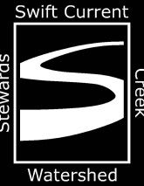





Table of contents

Executive Summary………………………………………………………………………3

1. Introduction………………………………………………………………………..4
2. Town of Herbert and its Water supply…………………………………4
3. Methodology……………………………………………………………………….7
4. Table 1: Planned Water Use Ratios for the Town of Herbert..9
5. Results and analysis……………………………………………………………..9
6. Conclusions………………………………………………………………………….10

Appendix A: 2017 Daily water usage for the Town of Herbert…………12

Appendix B: Daily pumping capacity calculations…………………………….13

**Executive Summary**

The Herbert Source Water Protection Plan Committee was formed to ensure that residents of the town and water users will have a safe and abundant supply of drinking water now and into the long term future. The committee identified the risks to both of the surface water and ground water that make up the town’s water supply. After the risks were identified, the committee then scored the likelihood of the event happening and the consequences of the event after it happened. These scores were then combined to determine the rankings for each of the potential risks identified. Once the potential risks of contamination to the water supply were ranked, management actions to eliminate or mitigate the risks were identified.

One of the risks that were identified was the use of surface water to ensure that the water consumption needs of Herbert were met. The management actions that were identified to eliminate or mitigate this risk was the development of a water use plan to determine the blend of surface and ground water and water quality sampling to determine the quality of the surface water going into the water treatment plant.

The plan that was developed is a preliminary plan designed to be a starting point for Herbert to set the blend of surface and ground water sources. Using a water sampling protocol to determine quality of the surface water used and the effects of the reservoirs and canals in the system that gets water to the treatment plant and information on water usage, this plan can be fully developed in consultation with water quality and water treatment experts considering water treatment and usage legislation and regulations.

1. **Introduction**

This preliminary water use plan is a result of the work of the Herbert Source Water Protection Planning Committee. Community Source Water Protection is one approach to prevent contamination of a community’s source water, including both surface and ground water sources. Source Water Protection (SWP) is a core component of Watershed Planning led by Water Security Agency (WSA). In 2016 WSA contracted Swift Current Creek Watershed Stewards (SCCWS) to perform rapid risk assessments on source water for communities in the Swift Current Creek Watershed and Southwestern Saskatchewan. The rapid risk assessment of the Town of Herbert’s source water showed that their supply was at risk of contamination. After reviewing the results of this assessment the Town of Herbert decided to undertake SWP with the assistance of SCCWS to protect and improve both ground and surface water sources it uses to supply drinking water to its residents.

Source Water Protection is the first step in the multi-barrier approach (MBA), which the Canadian Council of Ministers of Environment (CCME) defines as a “integrated system of procedures, processes and tools that collectively prevent or reduce the contamination of drinking water from source to tap in order to reduce risks to public health” (2002). The other barriers in the MBA include effective treatment, maintenance of the water distribution system, monitoring and emergency response planning. As the first step in the MBA, SWP is an essential component of any strategy to prevent or reduce contamination risks to a water system.

1. **Town of Herbert and its Water Supply**

The Town of Herbert is located in the Rural Municipality of Morse in southwestern Saskatchewan. It is on the #1 Highway about 50 kilometres east of Swift Current and 200 kilometres west of Regina. According to the Saskatchewan Municipal Directory Herbert’s population in 2017 was 856 people.

Herbert uses both surface water and ground water for its drinking water supply. The water supply was surface only until 2011, when water quality issues moved the town to drill water wells and upgrade the Water Treatment Plant (WTP) to treat this ground water. However, the wells do not supply enough good quality water during times of peak usage. In order to supply enough good quality water during peak use periods, the ground water is supplemented with surface water. However, high levels of organic matter in the surface water cause the filters of the Reverse Osmosis (RO) units in the WTP to become plugged, reducing the efficiency of the plant and increasing costs to replace the filters.

The ground water that Herbert uses is pumped into the WTP from a dug-out north of the town. For this report this will be referred to as the Herbert Dug-out. Herbert owns the land immediately adjacent to the dug-out. This dug-out is 466.2 dam3 in size. The catchment area of this dug-out is approximately 580 acres. This dug-out is filled as required by a six kilometer long pipeline from an Agriculture and Agri-Food Canada controlled reservoir west of Herbert. For this report this will be referred to as the Herbert Reservoir. This reservoir is 2,700 dam3 in size. Herbert Reservoir also supplies water to irrigation adjacent to it. There is 1,667 acres that are irrigated, with the potential to use 1,350 dam3 worth of water each year. There is some local run-off into the reservoir with a catchment area of approximately 640 acres. Most of the water in this reservoir comes from Highfield Dam southwest of Herbert via the Herbert Main Canal. This is a 26 kilometre canal that runs through cropland, pasture and tame forage and also supplies water for the Rush Lake Irrigation District. The canal is used in late May-early June and late July-early August depending on irrigation needs and water levels within the Herbert Reservoir.

Highfield Dam is supplied by Rush Lake Creek and some local run-off. If there is not enough water in Highfield Dam to supply Herbert’s drinking water needs and irrigation requirements, water levels in Highfield Dam can be augmented by water from the Swift Current Creek Watershed via the Swift Current Main Canal. This canal is 30 kilometres long, running from Swift Current to Highfield Dam and also supplies water to the Waldeck Irrigation District and some individual irrigation projects. Due to the increased rainfall in the last number of years, water levels in Highfield Dam have been sufficient to meet these needs. This has meant that no water has been moved from the Swift Current Creek to Highfield Dam since the spring of 2010.

The system that supplies surface water to Herbert is complex and covers a large area. In order to determine the impact that the waterbodies and canals have on water quality, a water quality testing regimen needs to be developed to work in conjunction with this preliminary water use plan. This regimen will not only determine the water quality of each waterbody and the impact of the quality of water going into the Water Treatment Plant, it will also identify when water quality is at its peak and at its lowest for each part of the system. This will allow the WTP operators to make decision on water use based not only on water needs but also on the quality of water going into the WTP.

Agriculture is the main land use along the entire system supplying surface water to Herbert. Upstream of Highfield Dam there is native forage immediately adjacent to Rush Lake Creek, with crop land next to the native forage. Around Highfield Dam there is a mix of cropland, native forage and seeded forage. The Herbert Main Canal has mostly native forage next to the canal, along with some seeded forage and a small amount of cropland. Herbert Reservoir is surrounded by cropland, native pasture and center pivot irrigation. The largest land use in the drainage area for the Herbert Dug-out is cropland.

The Herbert Dug-out experiences some algal growth in summer, despite aeration in the dug-out. This algal growth contributes to the increased organic matter in the surface water which in turn causes issues with the RO filters in the WTP. The algal growth is treated with copper sulphate as required. Herbert has started to experiment with hydrogen peroxide treatment of the Herbert Dug-out. The results of this trial have yet to be determined and the tests will continue into the spring.

SCCWS did complete some sampling and testing of the water at some of the waterbodies that hold surface water used by the Town of Herbert. Testing was to be completed to assess water quality as well as the potential for organic matter growth however miscommunication with the laboratory meant that samples collected in the fall of 2017 were only tested for chlorophyll and water quality parameters that are part of the well water quality monitoring panel. The early onset of winter meant that no further sampling was possible in 2017.

This sampling was completed to help determine the area to be studied in the SWP plan. Samples were taken at Highfield Dam, Herbert Reservoir, Herbert Dug-out and Rush Lake Creek upstream of the inlet into Highfield Dam. The results of the sampling showed that the water in the Herbert Dug-out was generally high quality. The only parameter that did not meet the Saskatchewan Drinking Water Guidelines was Sulfate at 511.5 mg/L as the guideline is 500 mg/L.

Water quality tends to improve as it moves from Highfield Dam to the Herbert Reservoir. This is likely due to reduced water levels in the waterbodies from less run-off and recharge during a dry and hot summer.

The wells that supply the groundwater are all deep wells being 200 to 400 feet deep. In the 225 metre radius around these wells is mostly municipal development including the town rink and elementary and high school.

The Town of Herbert does not regularly test the raw groundwater that it uses in the WTP. The water was tested in 2009 and 2010 before the wells were placed into service. The water quality of these wells is generally good quality with some excursions from the Saskatchewan Drinking Water Quality Standards and Objectives. The water from the well next to the water treatment plant has levels of the following that are higher than the objectives; total alkalinity, aluminum, iron, manganese, zinc and pH. The water from wells #2, #3 and #4 have levels of iron, sodium and total alkalinity that are higher than what are listed in the Saskatchewan Drinking Water Guidelines. In comparison to the surface water from the dug-out, the well water has higher levels of total alkalinity, bicarbonate, chloride, fluoride and sodium and lower levels of sulfate, total hardness, nitrogen, calcium, magnesium and potassium. Overall there is not much difference in the quality of the two sources of water; however the differences in the constituents of the water can cause issues with the WTP in terms of finding the most efficient method of water treatment.

During the Source Water Protection Planning process, the blending of surface water and ground water to meet demands was noted as one of the risks to Herbert providing a safe and abundant supply of water to its residents. This plan is part of the management actions identified by the committee to eliminate or mitigate the risks involved in the blending of the two water sources. The plan that is developed in this document is a preliminary plan to assist the Water Treatment Plant to determine how much of each water source to use at different times during the year. This plan is being developed to be flexible enough so that when more information is gained about water quality and water usage the plan can be modified.

1. **Methodology**

This water use plan is based on the following parameters in order of importance as determined by the Source Water Protection Planning Committee during the planning process.

1. Daily pumping capacity of the wells
2. Storage capacity at the WTP
3. Daily water usage
4. Capacity of WTP
5. Water quality especially of the surface water source

During the preparation of the water use plan, SCCWS reviewed the 2017 daily water usage provided by the Town of Herbert to determine the time frame that groundwater could be used as the sole source. Once this time frame was determined, surface water is added to the mix to meet the demands of the town at a given time.

From correspondence with the WTP operator the pumping capacity of the wells is 40-45 gallons per minute which is 150 to 170 liters per minute. The daily pumping capacity of the wells is 280,000 liters per day (See Appendix B for calculations). From the January to May the daily water use is near this amount or slightly above. The amount of ground water available is not enough to solely meet demands, so some surface water needs to be added in. January 1 to May 1 the water blend should be 85% ground water and 15% surface water. The storage capacity of the Water Treatment Plant is 1,133,000 liters which at peak consumption is less than three full days of storage. With this amount of storage the Town of Herbert cannot comfortably use only groundwater and rely on stored water.

The daily usage chart supplied by Herbert shows that water usage starts to increase during the long weekend in May as residents start to plant gardens and water lawns. For the month of May until the long weekend the water use ratio should be 75% groundwater and 25% surface water to allow for the town to prepare for the increased use over the long weekend. After the long weekend to June 10th the ratios should be 60% ground water 40% surface water.

At the end of May and beginning of June the Herbert Reservoir is filled with water from Highfield Dam during the irrigation period at Rush Lake Irrigation Project. In most years this is completed by June 5th. Therefore the Herbert Dug-out should be filled from the Herbert Reservoir around June 10 to ensure that the water pumped to the Dug-out is good quality. The replenishment of the water into the Herbert Reservoir from Highfield Dam should improve the quality of the water opposed to the water that has been in the Reservoir all fall and winter. The catchment area of the Herbert Reservoir is too small to rely on run-off to improve water quality in the spring. From June 10th to August 10th the ratio of water used should be 55% groundwater and 45% surface water. The dug-out should again be filled from the reservoir around August 10th after the second time water is ran into the Herbert Reservoir from Highfield Dam.

The ratio of water use from August 10th to September 10th should be 60% groundwater and 40% surface water. September 10th to October 31st use a ratio of 80% groundwater and 20% surface water. From November 1st to December 31st the mix should be 85% groundwater and 20% surface water.

1. **Table 1: Planned Water Use Ratios for the Town of Herbert**

|  |  |  |  |
| --- | --- | --- | --- |
| Start Date | End Date | Percent Groundwater | Percent Surface Water |
| January 1 | April 30 | 85% | 15% |
| May 1 | Approximately May 18 (Start of Long weekend) | 75% | 25% |
| May 19 | June 9 | 60% | 40% |
| June 10 | August 9 | 55% | 45% |
| August 10 | September 9 | 60% | 40% |
| September 10 | October 31 | 80% | 20% |
| November 1 | December 31 | 85% | 15% |

1. **Results and Analysis**

For this preliminary plan the percentage of use of each water source at a given time is based on how much water is needed during that time period. The percentage of the surface water used was selected to ensure that there is enough water to match the average daily water use during that time of the year. The treatment process used by the WTP is designed for groundwater. The intake and use of surface water may create issues with the WTP. It is imperative that the surface water used be kept to a minimum with enough coming in to ensure that supply needs are met. This ensures that the Water Treatment Plant will treat enough water to supply the daily needs while maintaining efficient water treatment. This will also ensure that there is sufficient water for 2 or 3 days if the WTP is inoperable.

If possible water should be only pumped into the dug-out from the Herbert Reservoir twice a year after water has finished running into the Herbert Reservoir from Highfield Dam. This should improve water quality in the Herbert Reservoir by replacing possibly stagnant water with a supply of fresher water. This will improve the water quality in the Herbert Dug-out by pumping in higher quality water. Implementation of a water testing regimen will help to determine if water quality will be improved, and by what factor it is improved, by pumping in water after the Herbert Reservoir has been refreshed. Testing will also pinpoint the time when water quality is the highest in the Herbert Reservoir to be pumped to the dug-out. Water in the reservoir needs to be tested before it is pumped to the dug-out.

The Herbert Reservoir becomes home to many geese and ducks during their fall migration. This may cause some water quality issues in the fall so all water pumping from the Herbert Reservoir to the Herbert Dug-out should be completed before this occurs and not again until more water is run into the reservoir. Again water testing before and after the arrival of the birds will help to determine their impact on water quality.

A water sampling and testing regimen is being developed to help to determine the water quality in the system that supplies surface water to the Town of Herbert and how it changes along the length of the system. These changes to water quality may change the percentage of each water source used and when they are used. It is important that the water use plan incorporates the water sampling results as they may show that the quality of the surface water is such that more can be used during times of peak use. This would also help to offset any possible increases in water consumption and population.

1. **Conclusions**

Groundwater alone is insufficient to supply the water needs of the Town of Herbert even during the winter months when consumption is lower, so surface water needs to be added to the system. The amount added increases during the summer months when consumption increases. Unfortunately the summer months is when the organic matter levels are the highest in the surface water coming from the Herbert Dug-out and this interferes with the efficient operation of the WTP’s RO system.

This water use plan is a preliminary plan based on information provided by the Town of Herbert and recommendations from the Herbert Source Water Protection Planning Committee. This plan is intended to be a starting point for the WTP operators to find a blend of surface and ground water in the WTP that ensures that water demands are met while the plant is operating efficiently. Further development of this water use plan needs to be mindful of legislation and regulations around municipal water treatment plants. To ensure that all regulatory requirements are met, the operators of the Herbert WTP need to involve experts in water management, water treatment and water quality when developing a long-term water use plan.

Water conservation education and incentives should be implemented to help alleviate issues with the need for more surface water to be added to the system in summer. This will also reduce pressure on the WTP to treat enough water to meet daily needs and will improve its efficiency.

The Town of Herbert should continue to investigate methods to pre-treat surface water in the Herbert Dug-out to improve the efficiency of the Water Treatment Plant when using surface water.

The Town of Herbert should investigate the costs of more treated water storage and the effect on water quality on water that has been stored for a longer period of time.

Appendix A: 2017 Daily Water Usage Town of Herbert as prepared by the operators of the Herbert WTP

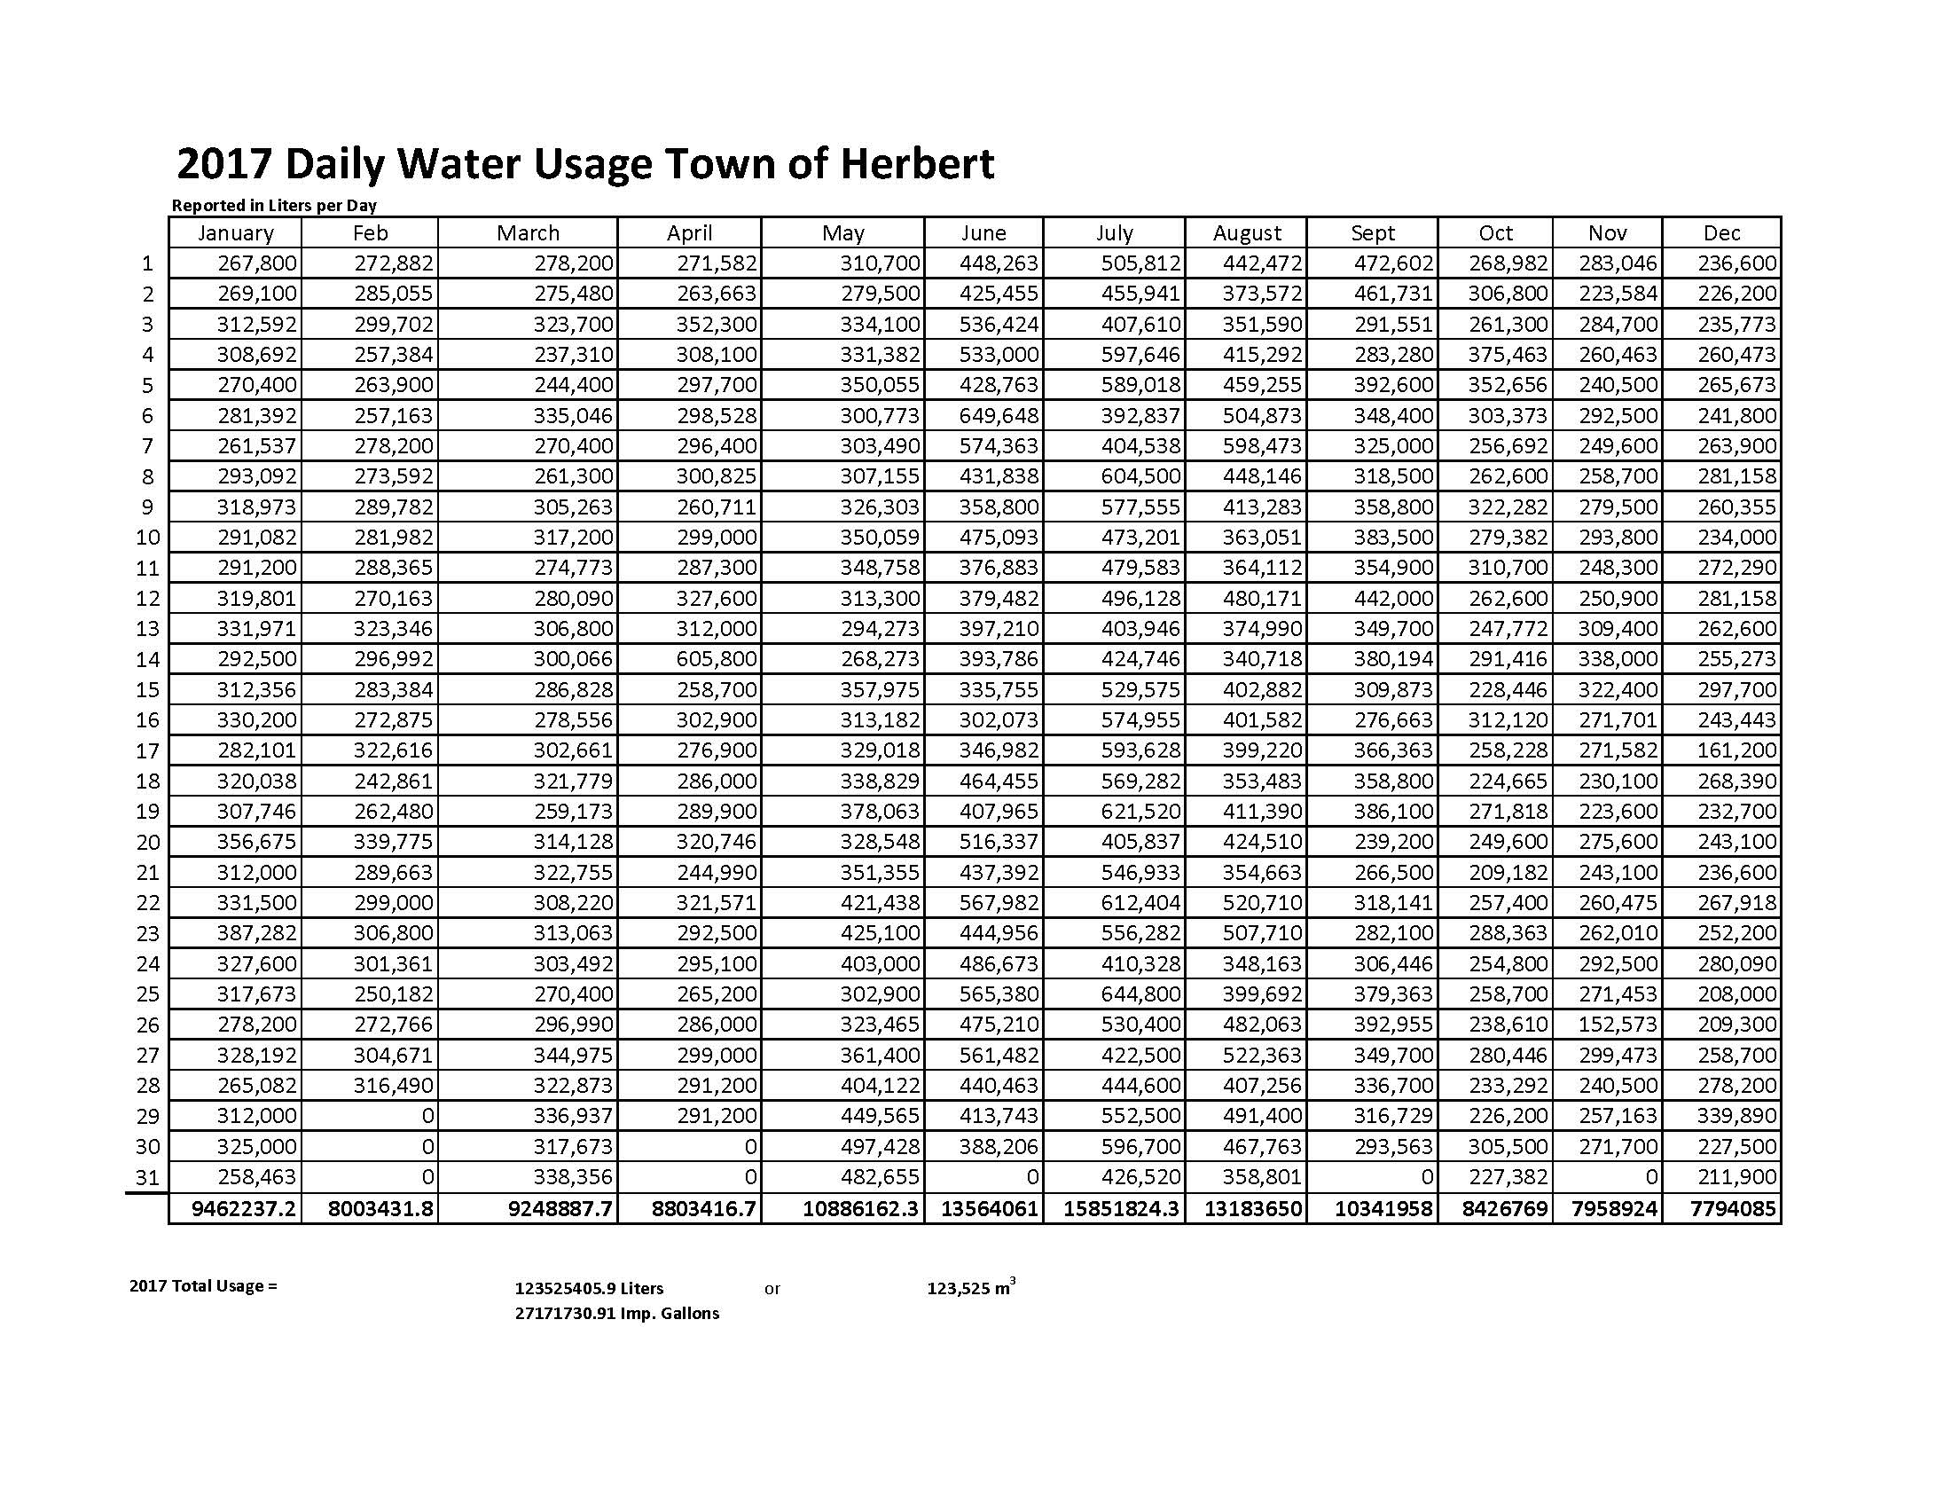

Appendix B: Calculation of Daily Pumping Capacity of Wells Used by Town of Herbert

Pumping Capacity of Well per Town of Herbert = 40 to 45 gallons per minute

40 gallons per minute X 60 minutes per hour = 2,400 gallons per hour X 24 hours per day = 57,600 gallons per day

57,600 gallons per day X 4.5461 liters/gallon = 261,855 liters/day

45 gallons per minute X 60 minutes per hour = 2,700 gallons per hour X 24 hours per day = 64,800 gallons per day

64,800 gallons per day X 4.5461 liters/gallon = 294,588 liters/day

Average pumping capacity = 280,000 liters/day