Herbert Source Water Protection Planning Committee

Final Report March 15, 2018

Produced by Swift Current Creek Watershed Stewards

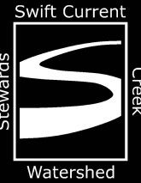



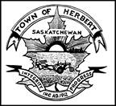

**Table of Contents**

Acknowledgements……………………………………………………………………………………………………………….……3

List of Tables………………………………………………………………………………………………………………………….……4

List of Figures………………………………………………………………………………………………………………………………5

Executive Summary……………………………………………………………………………………………………………………..6

1. Introduction…………………………………………………………………………………………………………………….7
2. Stages of Source Water Protection Planning…………………………………………………………………...7

2.1 Stage 1: Steering Committee……………………………………………………………………………………..8

2.2 Stage 2: Source Water Assessment…………………………………………………………………………….8

2.3 Stage 3: Land Management Actions……………………………………………………………………………8

2.4 Stage 4: Implementation…………………………………………………………………………………………….8

2.5 Stage 5: Review of Source Water Protection Plan……………………………………………………….8

3. Town of Herbert and its water supply……………………………………………………………………………………….9

4. Source Water Protection Plan Methodology……………………………………………………………………………10

4.1 Stage 1: Steering Committee…………………………………………………………………………………….10

4.2 Stage 2: Source Water Assessment…………………………………………………………………………..10

4.2.1 Description of land use and characterization of surface and ground water.14

4.2.2 Risk Inventory……………………………………………………………………………………………30

4.2.3 Qualitative Risk Assessment………………………………………………………………………32

4.3 Stage 3: Land Management Actions…………………………………………………………………………37

4.3.1 Analysis…………………………………………………………………………………………………….46

4.4 Stage 4: Implementation and Plan Review……………………………………………………………….47

4.5 Stage 5: Five Year Review…………………………………………………………………………………………47

5. Conclusion………………………………………………………………………………………………………………………………47

**Acknowledgements**

The Swift Current Creek Watershed Stewards would like to thank the many groups and individuals who worked to make this committee happen. First of all thank you to the council of the Town of Herbert who saw this project as a way to solve some of the issues that the town faces in supplying a safe and abundant supply of drinking water to residents. Thank you to Terry Voth who supplied much of the technical information about the Water Treatment Plant and Herbert’s water supply. Thank you to Michelle Mackow for helping to organize meetings and for providing background information. Thank you to all of the members of the committee who took time out of their busy schedule to contribute to this project. Thank you to Water Security staff who provided technical assistance with this project. Thank you to Water Security Agency for providing partial funding of this project through the Project Incentive Fund.

**List of Tables**

Table 1: Members of Herbert Source Water Protection Planning Steering Committee………8

Table 2: Groundwater Source Information well next to Treatment Plant…………………………17

Table 3: Groundwater Source Information Well #2………………………………………………………….19

Table 4: Groundwater Source Information Well #3………………………………………………………….21

Table 5: Groundwater Source Information Well #4………………………………………………………….23

Table 6: Groundwater Source Information Well #6………………………………………………………….25

Table 7: Surface water Source Information Herbert Dug-out……………………………………………27

Table 8: Surface water Source Information Herbert Reservoir…………………………………………28

Table 9: Surface water Source Information Highfield Dam……………………………………………….29

Table 10: Risk Inventory………………………………………………………………………………………..…………30

Table 11: Likelihood Criteria…………………………………………………………………………………………….33

Table 12: Consequence Criteria……………………………………………………………………………………….34

Table 13: Risk Analysis………………………………………………………………………………………………………34

Table 14: Qualitative Analysis…………………………………………………………………………………………..35

Table 15: Voluntary Risk Management Actions………………………………………………………………..37

Table 16: Risk Management Action Plans………………………………………………………………………...41

Table 17: Glossary of Terms……………………………………………………………………………………………..48

**List of Figures**

Figure 1: Drainage area of Herbert Dug-out……………………………………………………………………11

Figure 2: Drainage area of Agriculture and Agri-Food Canada Herbert Reservoir……………11

Figure 3: Drainage area of Highfield Dam……………………………………………………….………………12

Figure 4: Location of and 225 metre radius around Well #1098……………………….…………….12

Figure 5: Location of and 225 metre radius around Well #2……………………………………….….13

Figure 6: Location of and 225 metre radius around Well #3……………………………………….….13

Figure 7: Location of and 225 metre radius around Well #4…………………………………………..13

Figure 8: Location of and 225 metre radius around Well #6…………………………………….…….14

**Executive Summary**

The Herbert Source Water Protection Plan Committee was formed to ensure that residents of the town and water users will have a safe and abundant supply of drinking water now and into the long term future. The committee identified the risks to both of the surface water and ground water that make up the town’s water supply. After the risks were identified, the committee then scored the likelihood of the risk occurring and the consequences to the water supply if the risk ocurred. These scores were then combined to determine the rankings for each of the potential risks identified. Once the potential risks of contamination to the water supply were ranked, management actions to eliminate or mitigate the risks were identified. The potential contamination risks to the ground and surface water source, their rankings and the management actions are the basis of this report.

The system that supplies surface water to Herbert is an extensive system of reservoirs and canals. If the committee had looked at the potential risks along the entire system, there was a real possibility that the committee would become overwhelmed with the task of identifying all of the risks. This would have slowed the process creating the possibility that the plan would not be created. To ensure that the committee could create a workable plan, it decided to only look at the potential risks starting at Highfield Dam and work downstream to the dug-out from which water is pumped to the Water Treatment Plant (WTP).

The committee identified many risks common to all small community water systems. However using both ground and surface water sources and the system that gets surface water to the town makes Herbert unique to other towns and other Source Water Protection Plans. The plan developed by this committee recognizes these facts and that the use of surface water poses problems for the efficient operation of the WTP. To ensure that the WTP operates at peak efficiency the committee developed a plan that works to have the surface water entering the WTP is the highest quality possible.

1. **Introduction**

Community Source Water Protection is an approach to preventing contamination of a community’s source water including both surface and ground water sources. Source Water Protection (SWP) is a core component of watershed planning led by Water Security Agency (WSA). In 2016 WSA contracted Swift Current Creek Watershed Stewards (SCCWS) to perform rapid risk assessments of water sources of communities in the Swift Current Creek Watershed and southwestern Saskatchewan. The rapid risk assessment of the Town of Herbert’s source water showed that this supply was at risk of contamination. After reviewing the results of this assessment the Town of Herbert decided to undertake SWP with the assistance of SCCWS to protect and improve both of the ground and surface water sources it uses to supply drinking water to its residents.

SWP is the first step in the multi-barrier approach (MBA) which the Canadian Council of Ministers of Environment (CCME) defines as an, “integrated system of procedures, processes and tools that collectively prevent or reduce the contamination of drinking water from source to tap in order to reduce risks to public health” (2002). The other barriers in the MBA include effective treatment, maintenance of the water distribution system, monitoring and emergency response planning. As the first step in the MBA, SWP is an essential component of any strategy to prevent or reduce contamination risks to a water system.

A five stage SWP planning model developed by Dr. Robert Patrick of the University of Saskatchewan was adopted to complete the SWP for the Town of Herbert. The five steps are development of a steering committee, assessment of the source water, development of land management actions, implementation of the land management actions and review of the plan.

1. **Stages of Source Water Protection Planning** 
   1. **Stage 1: Steering Committee**

Members of the committee were chosen to represent a cross section of the stakeholders in the quality of Herbert’s source water supply. Steering committee members were selected for their knowledge of the water system of the Town of Herbert as well as knowledge of the land surrounding Herbert’s water supply and the system that supplies surface water to the Town of Herbert.

**Table 1: Members of the Herbert Source Water Protection Planning Steering Committee**

|  |  |  |
| --- | --- | --- |
| Name | Title | Organization |
| Mitch Froyman | Environmental Technologist | Matrix Environmental Solutions |
| Jenna Furseth | Environmental Projects Officer | Water Security Agency |
| Rod Lemon | Environmental Projects Officer | Water Security Agency |
| Michelle Mackow | Chief Administrative Officer | Town of Herbert |
| Harold Martens | Reeve | RM of Excelsior |
| Ken Mathies | Member at Large | Town of Herbert |
| Ron Mathies | Mayor | Town of Herbert |
| Michael Montgomery | Councillor | RM of Morse |
| Gary Neil | Manager, Watershed Services | Water Security Agency |
| Dallas Peters | BMP Technician | Swift Current Creek Watershed Stewards |
| Doreen Schroeder | Member at Large | Town of Herbert |
| Tom Schwartz | Regional Services Manager | Saskatchewan Ministry of Agriculture |
| Kevin Steinley | Executive Director | Swift Current Creek Watershed Stewards |
| Terry Voth | Water Treatment Plant Operator | Town of Herbert |

**2.2 Stage 2: Source Water Assessment**

In this stage information about water sources used by the Town of Herbert was collected. Water quality of both surface and ground water was determined. The catchment areas of surface water sources were completed. Land uses in the catchment areas were inventoried, potential contamination events were identified. Risk created by the potential contamination events was assessed.

**2.3 Stage 3: Land Management Actions**

The information gathered in Stage 2 led to the development of land actions which eliminate or manage risks to drinking water from contamination events. This stage is complete once the SWP plan and final report are completed.

**2.4 Stage 4: Implementation**

Once the SWP plan is complete, the focus shifts to the implementation of the land management actions contained in this plan. This stage should last for five years.

**2.5 Stage 5: Review of SWP Plan**

The SWP plan is a document that has plans for land management to protect water sources and as such it needs be reviewed constantly. After five years the steering committee should reconvene to review the plan to determine if land management actions have had the desired results and if new actions need to be implemented to address any new risks that arose in the past five years.

1. **Town of Herbert and its Water Supply**

The Town of Herbert is located in the Rural Municipality of Morse in southwestern Saskatchewan. It is on the #1 Highway about 50 kilometres east of Swift Current and 200 kilometres west of Regina. According to the Saskatchewan Municipal Directory Herbert’s population in 2017 was 856 people.

Herbert uses both surface water and ground water for its drinking water supply. The water supply was surface water only until 2011, when water quality issues moved the town to drill water wells and upgrade the Water Treatment Plant (WTP) to treat this ground water. However, the wells do not supply enough good quality water during times of peak usage and to supply enough good quality water during these periods, ground water is supplemented with surface water. However, high levels of organic matter in the surface water cause the filters of the Reverse Osmosis (RO) units in the WTP to become plugged, reducing the efficiency of the plant and increasing costs to replace the filters.

The surface water that Herbert uses is pumped into the WTP from a dug-out north of the town, which will be referred to as the Herbert Dug-out in this report. Herbert owns the land immediately adjacent to the dug-out. This dug-out is 466.2 dam3 in size with a catchment area of approximately 580 acres. This dug-out is filled as required by a six kilometre long pipeline from an Agriculture and Agri-Food Canada (AAFC) controlled reservoir west of Herbert. For this report this reservoir will be referred to as the Herbert Reservoir. This reservoir is 2,700 dam3 in size. The Herbert Reservoir also supplies water to irrigation adjacent to it. There is 1,667 acres that are irrigated, with the potential to use 1,350 dam3 worth of water each year. There is some local run-off into the reservoir with a catchment area of approximately 640 acres. Most of the water in this reservoir comes from Highfield Dam southwest of Herbert via the Herbert Main Canal. This is a 30 kilometre canal that runs through cropland, pasture and tame forage and also supplies water for the Rush Lake Irrigation District. Water is generally run in the canal in late May-early June and late July-early August depending on irrigation needs and water levels within the Herbert Reservoir.

Highfield Dam is supplied by Rush Lake Creek and some local run-off. If there is not enough water in Highfield Dam to supply Herbert’s drinking water needs and irrigation requirements, water levels in Highfield Dam can be augmented by water from the Swift Current Creek Watershed via the Swift Current Main Canal. This canal is 30 kilometres long, running from Swift Current to Highfield Dam and also supplies water to the Waldeck Irrigation District and some individual irrigation projects. Due to the increased rainfall in the last number of years, water levels have been sufficient to meet these needs. This has meant that no water has been moved from the Swift Current Creek to Highfield Dam since the spring of 2010.

The complexity and size of the system supplying surface water to the Town of Herbert could have made the mandate of the SWP committee overwhelming by having to assess all of the risks with in the Rush Lake Sub-basin and Swift Current Creek Watershed. As water has not been moved from the Swift Current Creek Watershed since 2010 and any contamination of the Swift Current Creek below the City of Swift Current can easily be kept away from Highfield Dam the Herbert SWP Steering Committee decided that it would only look at the risks to Herbert’s water supply starting at Highfield Dam and working its way to Herbert’s WTP including the ground water wells within the Town of Herbert.

1. **Source Water Protection Plan Methodology**

This plan followed the model of Source Water Protection developed by Dr. Robert Patrick of the University of Saskatchewan as discussed in the introduction

**4.1 Stage 1: Steering Committee**

Stakeholders in Herbert’s water supply were selected as Steering Committee members. The committee included the WTP operator to provide information on the treatment plant and issues that it may arise with the operation of the plant. Also on the committee were members of Herbert’s Town Council and residents to provide insight into the issues faced by the town and residents and to give possible mitigation factors to these risks. Water Security Agency personnel have attended all meetings to give technical support to the community. A representative of the Rural Municipality of Excelsior in which the Herbert Main Canal and Herbert Reservoir exist and a representative of the Rural Municipality of Morse in which Herbert is were also in attendance to provide information on possible risks and the management actions that pertain to the respective Rural Municipalities. SCCWS personnel assisted the committee by facilitating meetings and recording meeting proceedings.

**4.2** **Stage 2: Source Water Assessment**

As discussed in the introduction the Town of Herbert uses a blend of surface and ground water with the surface water coming from a long distance through an extensive system of canals and waterbodies. The different drainage areas have been delineated separately. For the groundwater wells, a 225 metre radius was established for the rapid risk assessment to look at the risks that could affect the wells.

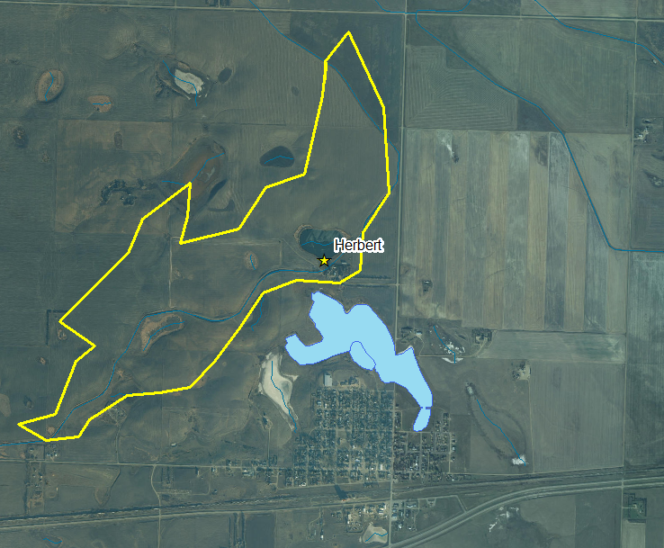

Figure 1: Drainage area for the Herbert Dug-out

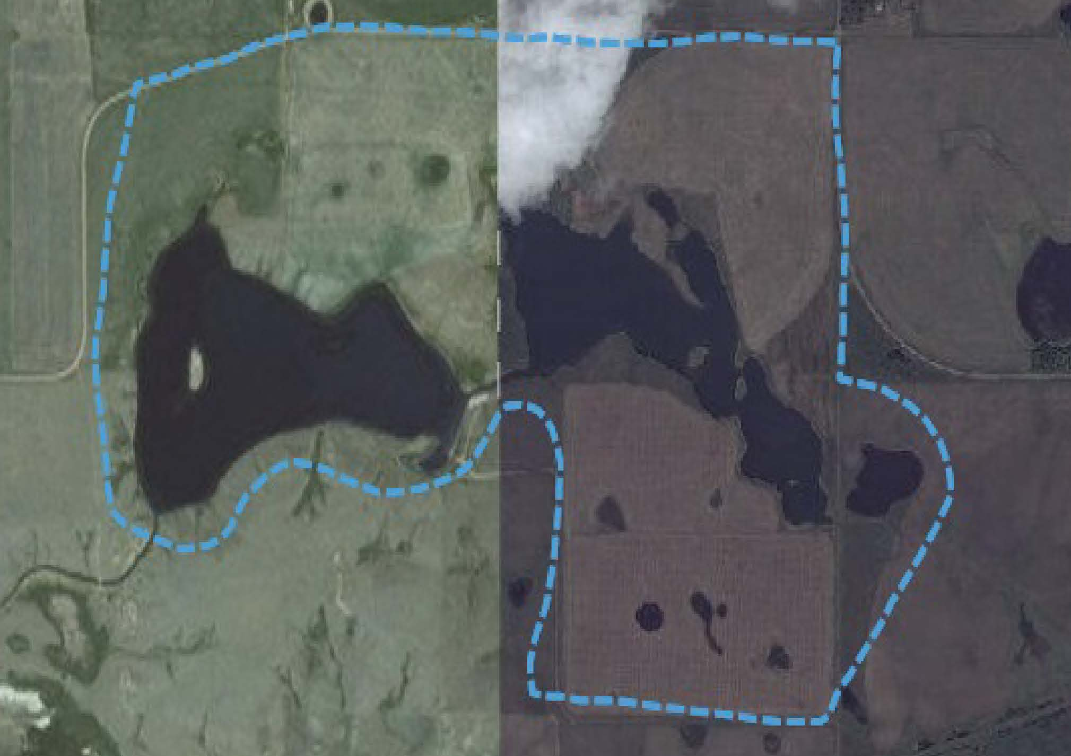

Figure 2: Drainage area for the AAFC Herbert Reservoir

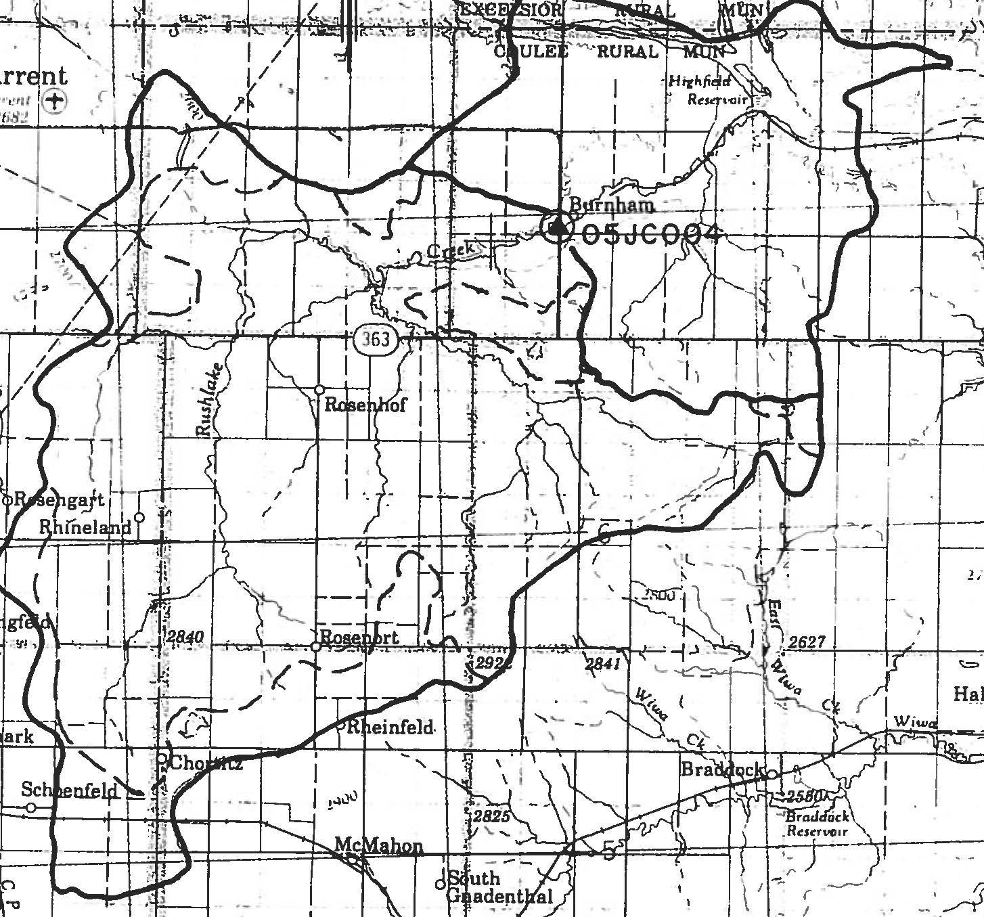

Figure 3: Drainage Area for Highfield Dam

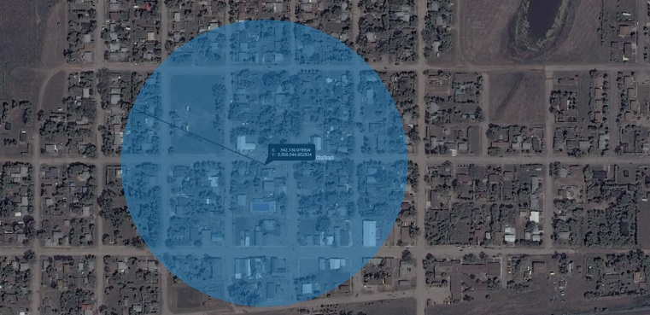

Figure 4: Location of and 225 metre radius around Herbert Well #1098

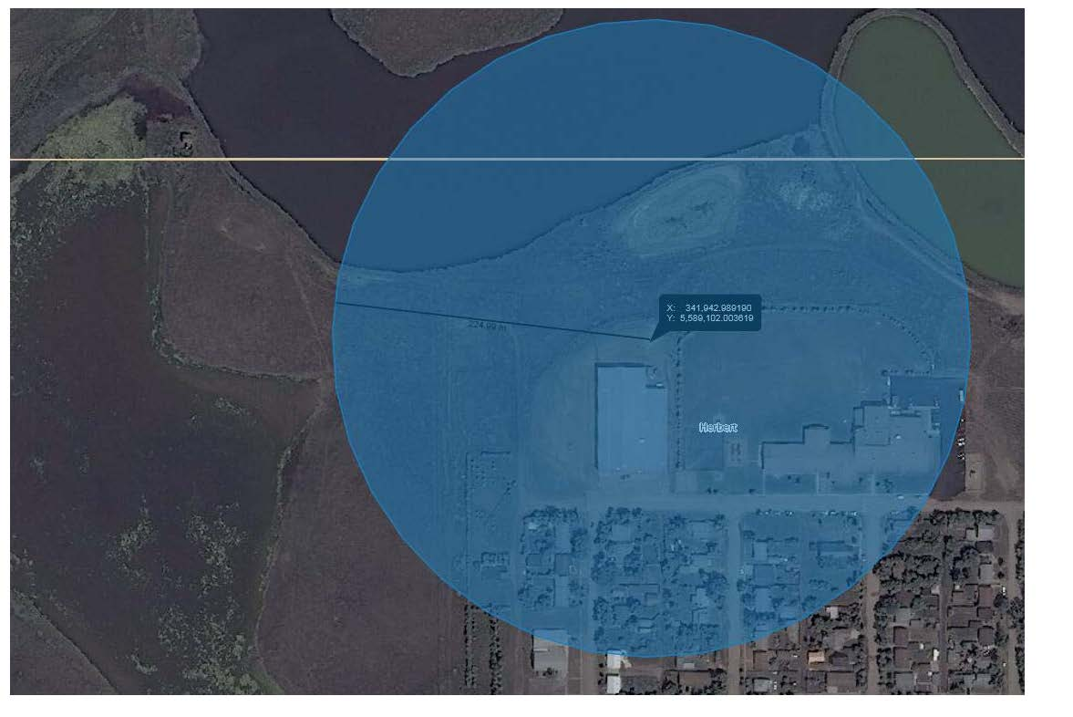

Figure 5: Location of and 225 metre radius around Herbert Well #2

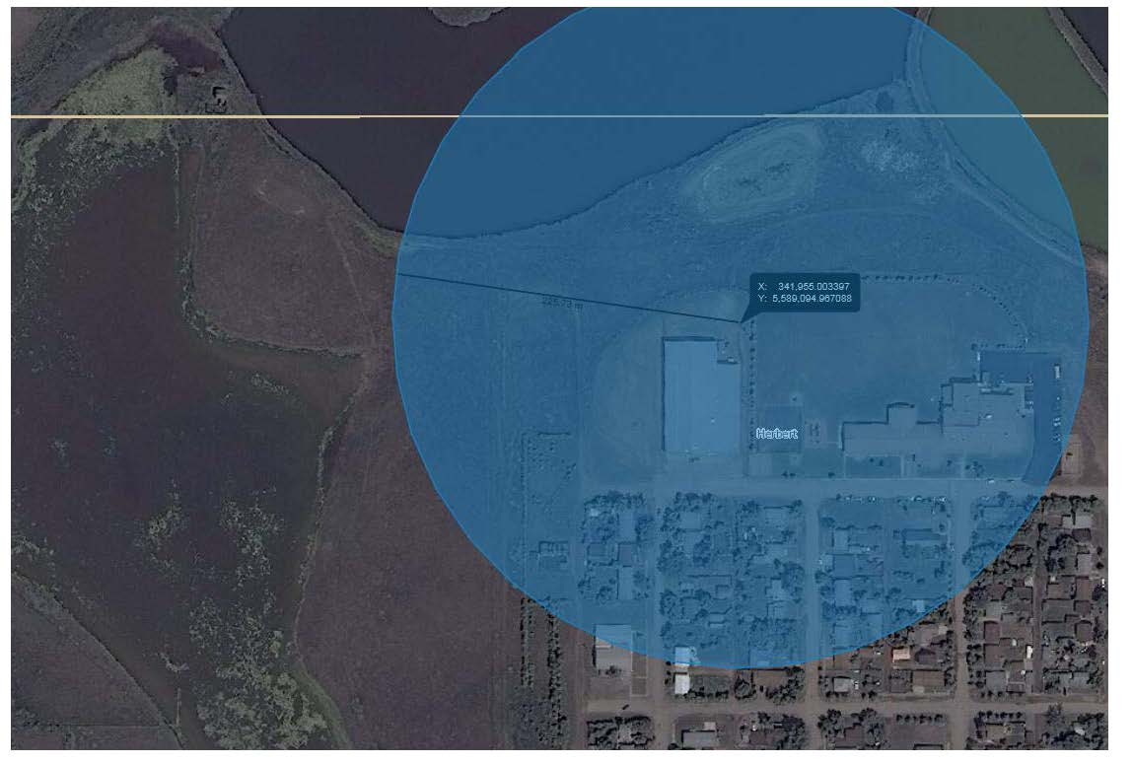

Figure 6: Location of and 225 metre radius around Herbert Well #3

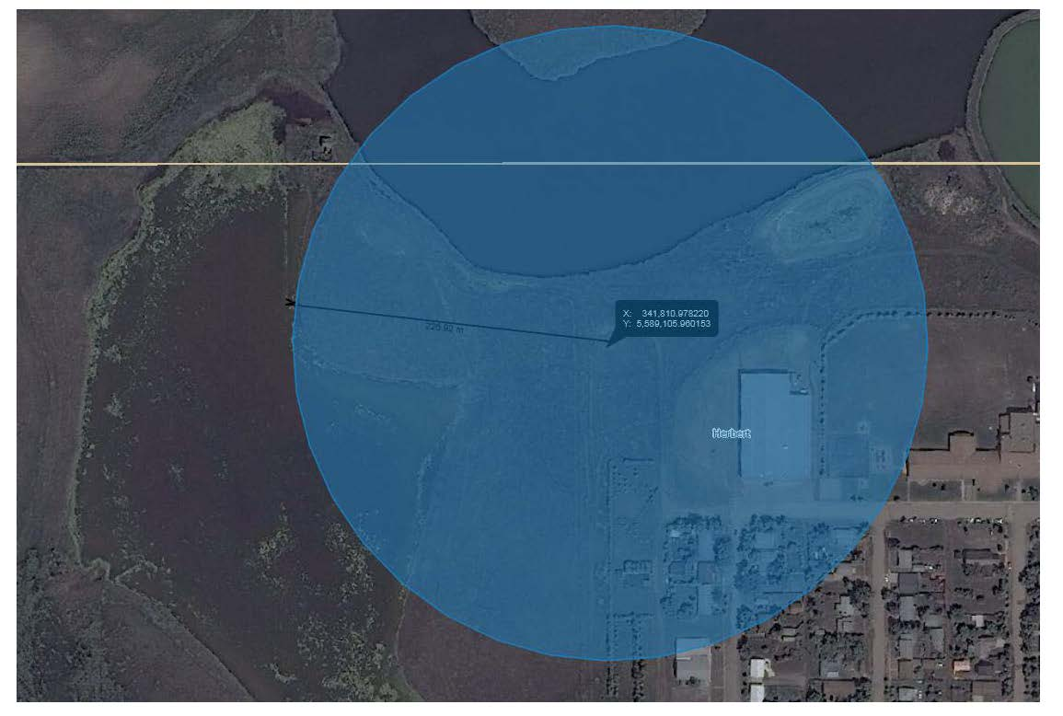

Figure 7: Location of and 225 metre radius around Herbert Well #4

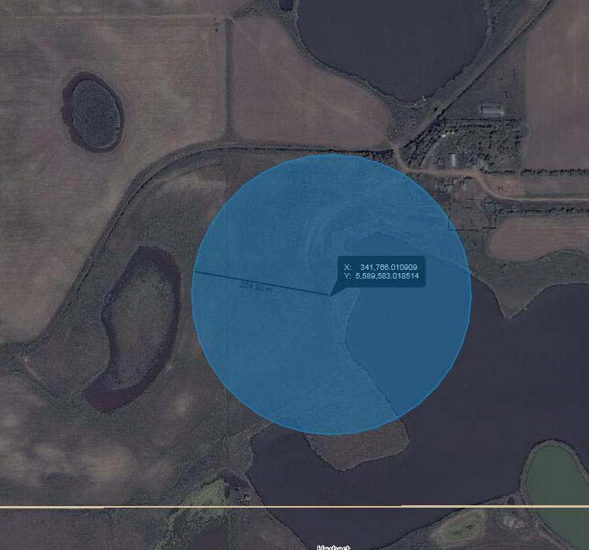

Figure 8: Location of and 225 meter radius around Herbert Well #6

**4.2.1 Description of land use and characterization of surface and ground water sources**

Agriculture is the main land use along the entire system supplying surface water to Herbert. Upstream of Highfield Dam there is native forage immediately adjacent to the creek with crop land next to the native forage. Around Highfield Dam there is a mix of cropland, native forage and seeded forage. The Herbert Main Canal has mostly native forage next to the canal along with some seeded forage and a small amount of cropland. Herbert Reservoir is surrounded by cropland, native pasture and center pivot irrigation. The largest land use in the drainage area for the Herbert Dug-out is cropland.

The Herbert Dug-out experiences some algal growth in summer despite aeration in the dug-out. This algal growth contributes to the increased organic matter in the surface water which in turn causes issues with the RO filters in the WTP. The algal growth is treated with Polydex from Cleartech as required. Herbert has started to experiment with hydrogen peroxide treatment of the Herbert Dug-out. The results of this trial have yet to be determined and the tests will continue into the spring.

SCCWS did complete some sampling and testing of the water at some of the waterbodies that hold surface water used by the Town of Herbert in the fall of 2017. Testing was to be completed to assess water quality as well as the potential for organic matter growth. However miscommunication with the laboratory meant that samples collected were only tested for chlorophyll and water quality parameters that are part of the well water quality monitoring panel. The early onset of winter in 2017 meant that no further testing was possible in 2017.

This sampling was completed to help determine the area to be studied in the SWP plan. Samples were taken at Highfield Dam, Herbert Reservoir, Herbert Dug-out and Rush Lake Creek upstream of the inlet into Highfield Dam. The results of the sampling showed that the water in the Herbert Dug-out was generally high quality. The only parameter that did not meet the Saskatchewan Drinking Water Guidelines was Sulfate at 511.5 mg/L which has a limit of 500 mg/L.

Water quality tends to improve as it moves from Highfield Dam to the Herbert Dug-out. This is likely due to reduced water levels in the waterbodies from less run-off and recharge during a dry and hot summer. The development of an effective water sampling regimen to determine effective water use is one of the goals of the SWP Committee.

The wells that supply the groundwater are all deep wells being 200 to 400 feet deep. The 225 metre radius around these wells is mostly municipal development, including the town rink and elementary and high school.

The Town of Herbert does not regularly test the groundwater that it uses in the WTP. The water was tested in 2009 and 2010 before the wells were placed into service. The water quality of these wells is generally good quality with some excursions from the Saskatchewan Drinking Water Quality Standards and Objectives. The water from the well next to the water treatment plant has levels of the following that are higher than the objectives: total alkalinity, aluminum, iron, manganese, zinc and ph. The water from wells #2, #3 and #4 have levels of iron, sodium and total alkalinity that are higher than what are listed in the Saskatchewan Drinking Water Guidelines. In comparison to the surface water from the dug-out, the well water has higher levels of total alkalinity, bicarbonate, chloride, fluoride and sodium and lower levels of sulfate, total hardness, nitrogen, calcium, magnesium and potassium. Overall there is not much difference in the quality of the two sources of water; however the differences in the constituents of the two sources of water makes it difficult for the WTP to find the most effective method of water treatment. The development of a water use plan as part of this Source Water Protection Plan will work to alleviate some of these issues.

Tables 2 to 6 contain information on the groundwater sources that are used by Herbert, including depth of the well, the aquifer that water is drawn from and the land uses immediately surrounding the well. The well driller’s report for each well follows the information for each well.

Tables 7 to 10 contain information on the surface water sources that are in the system that supplies the groundwater to Herbert, including capacity of reservoir, catchment area and land type around each reservoir.

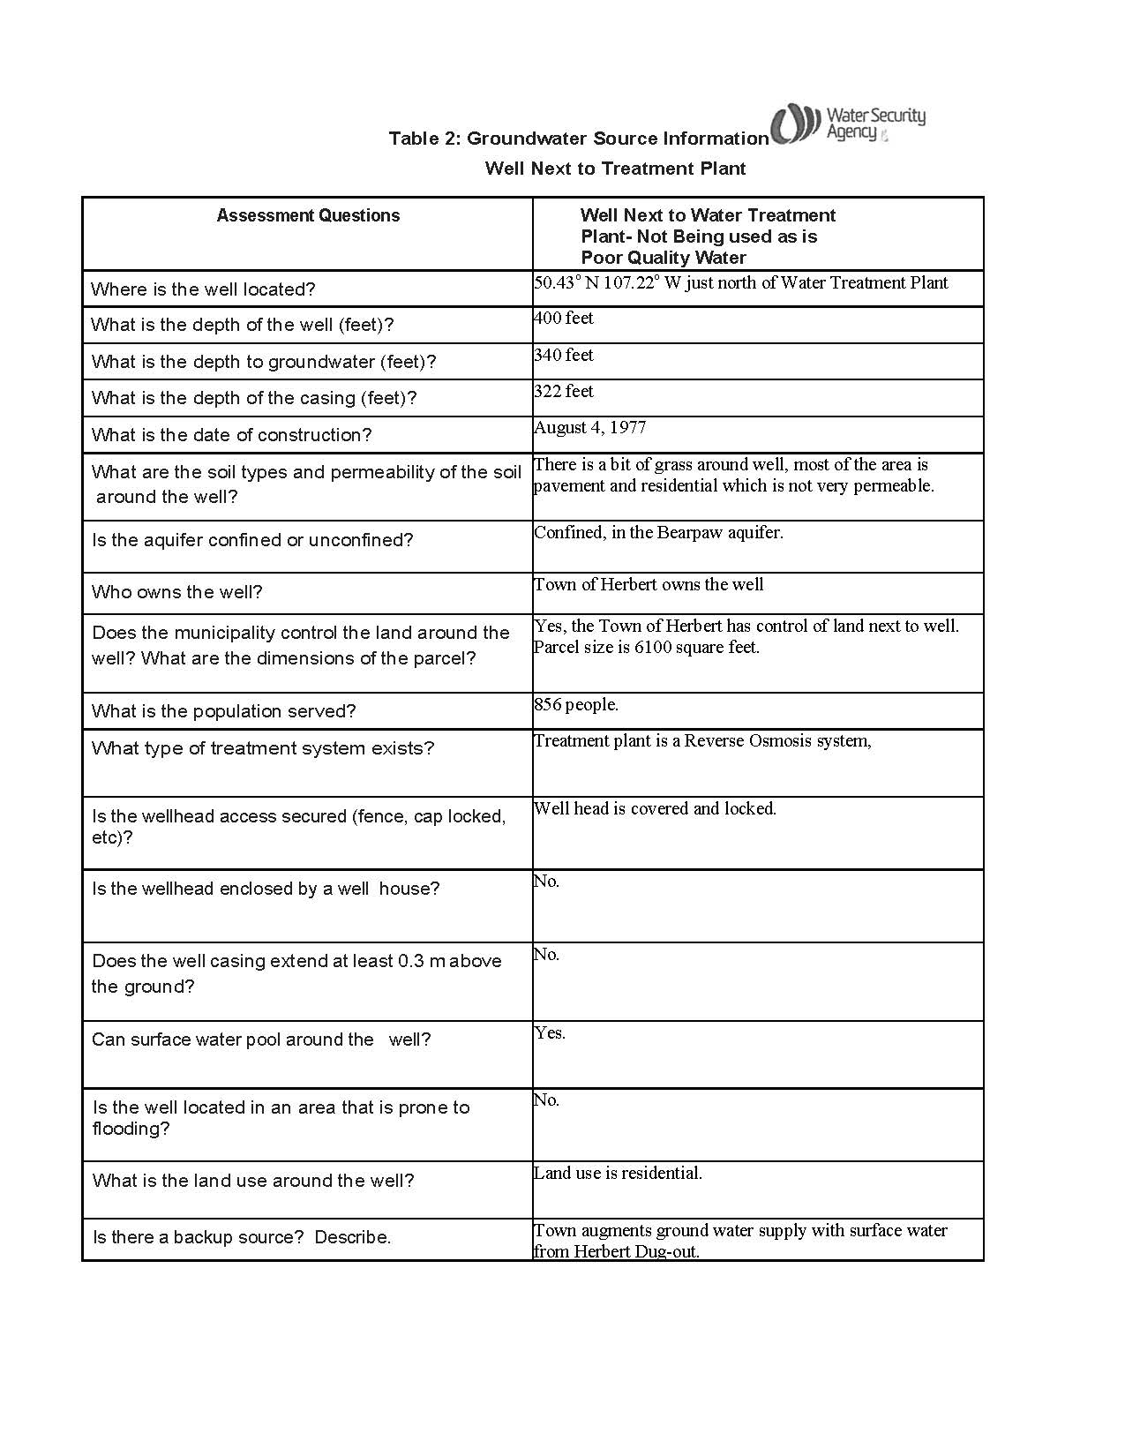

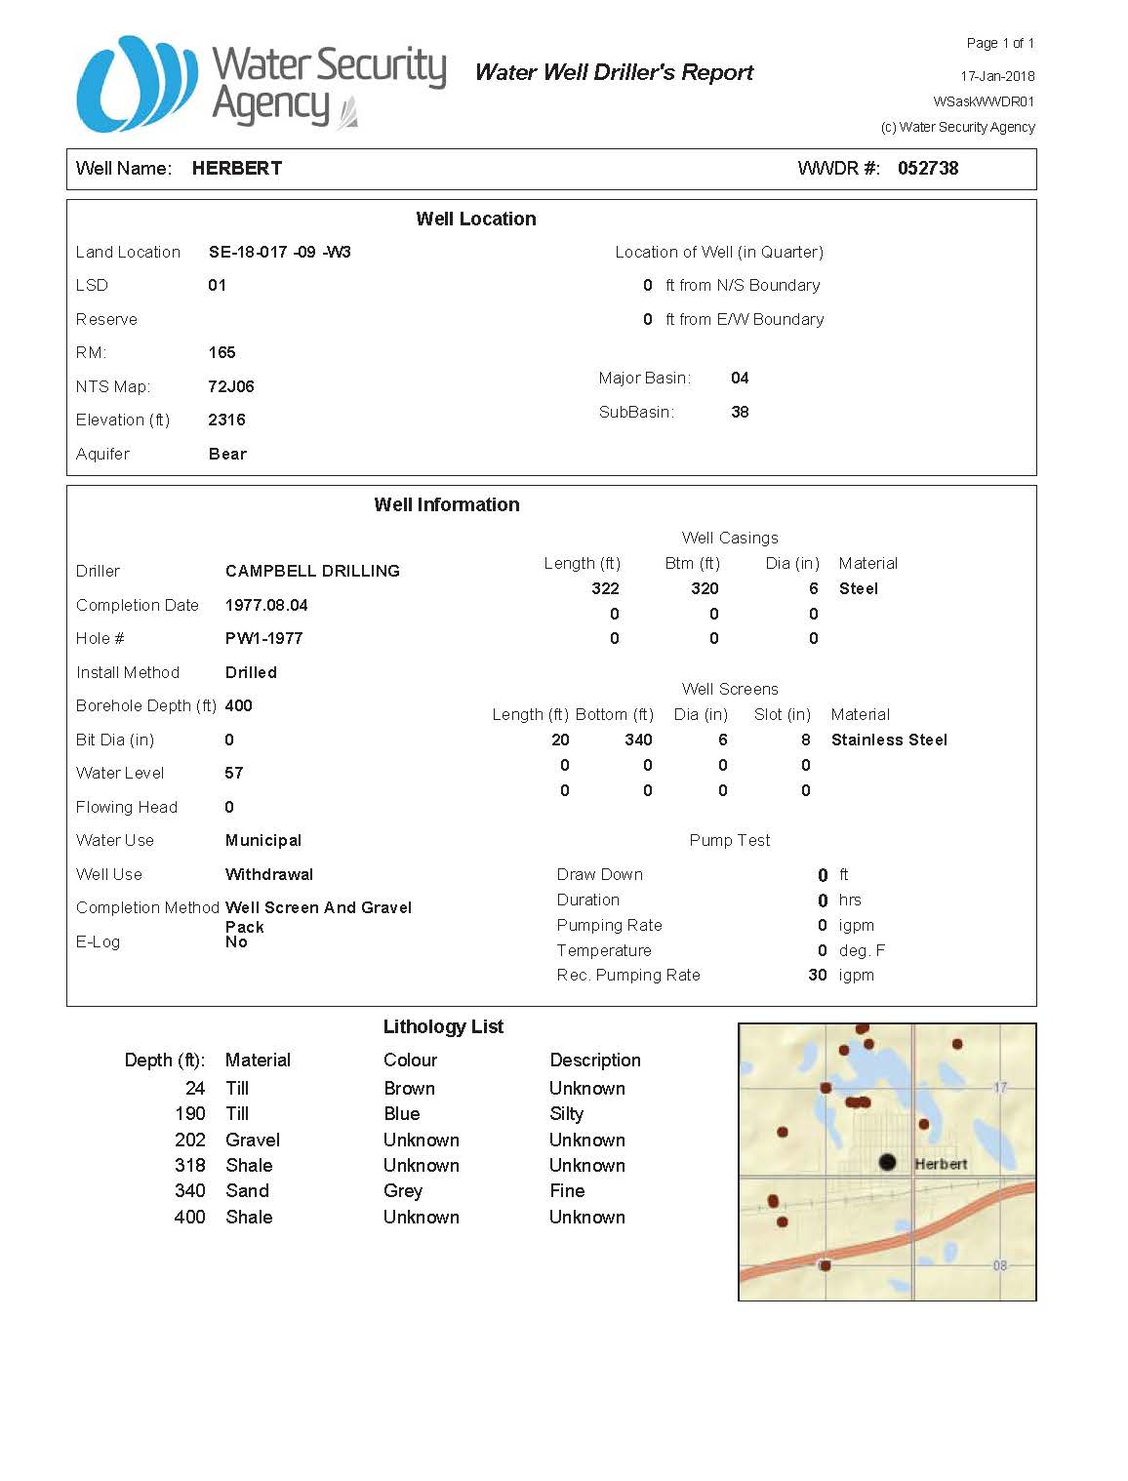

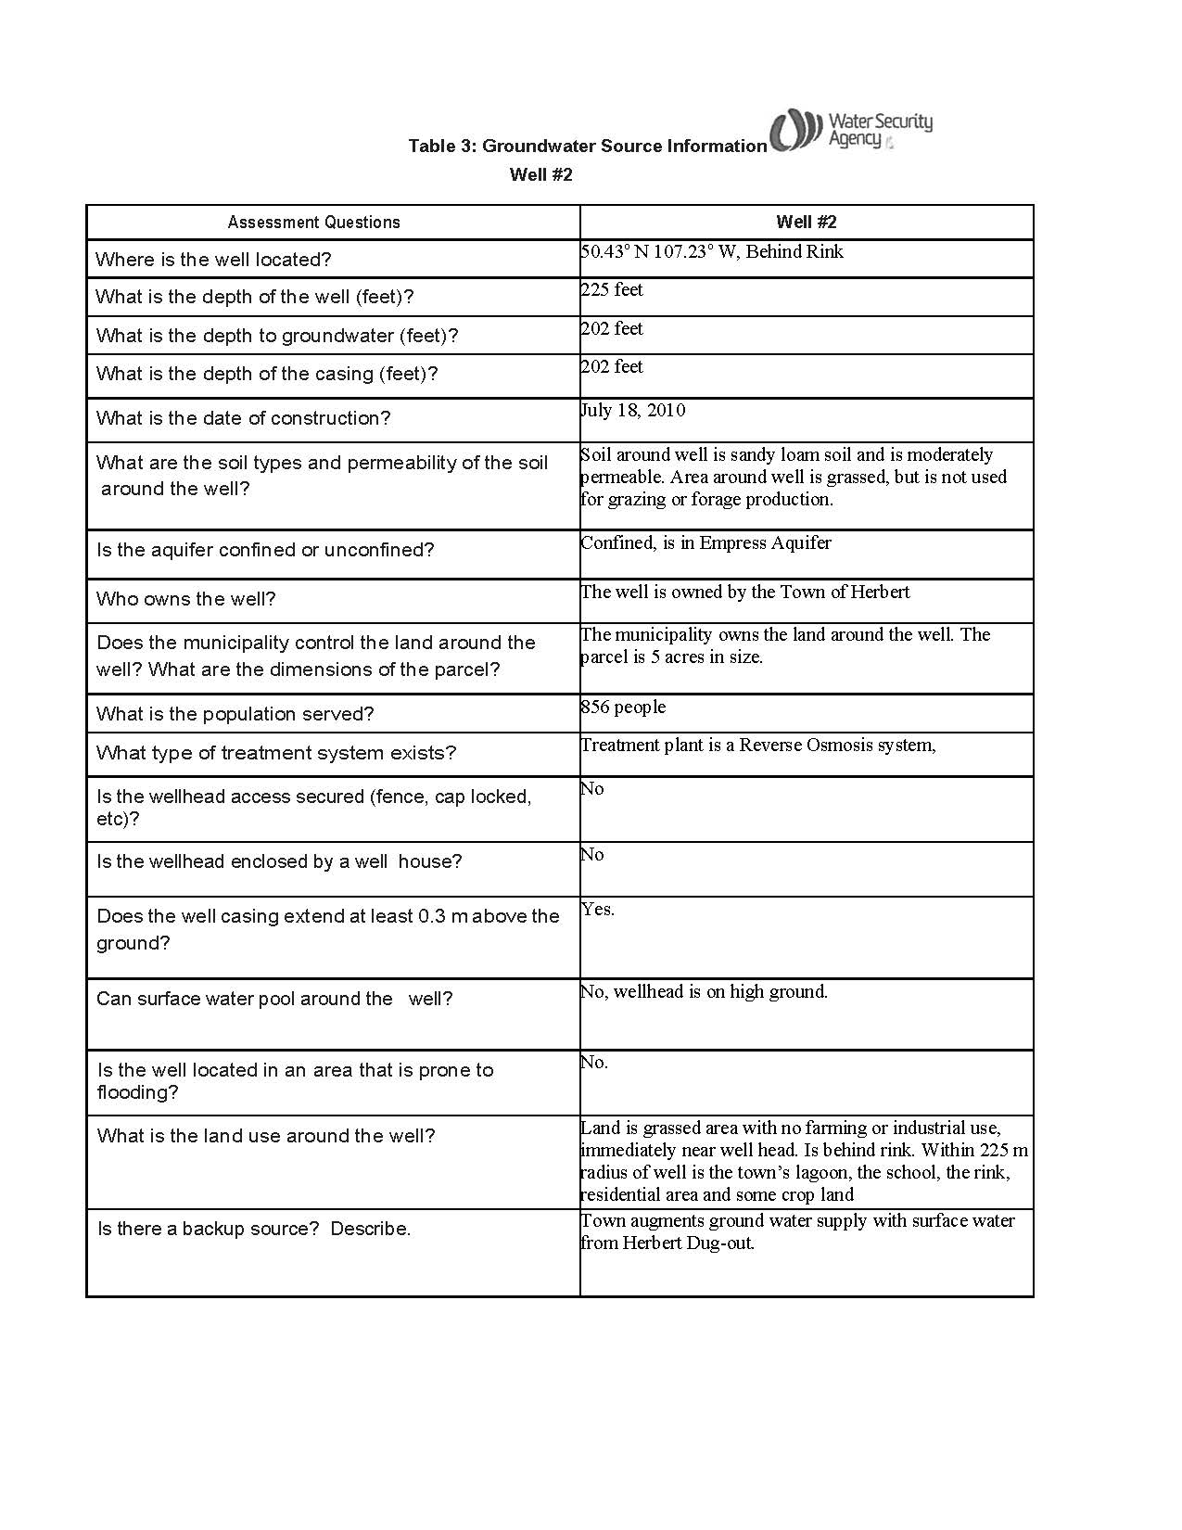

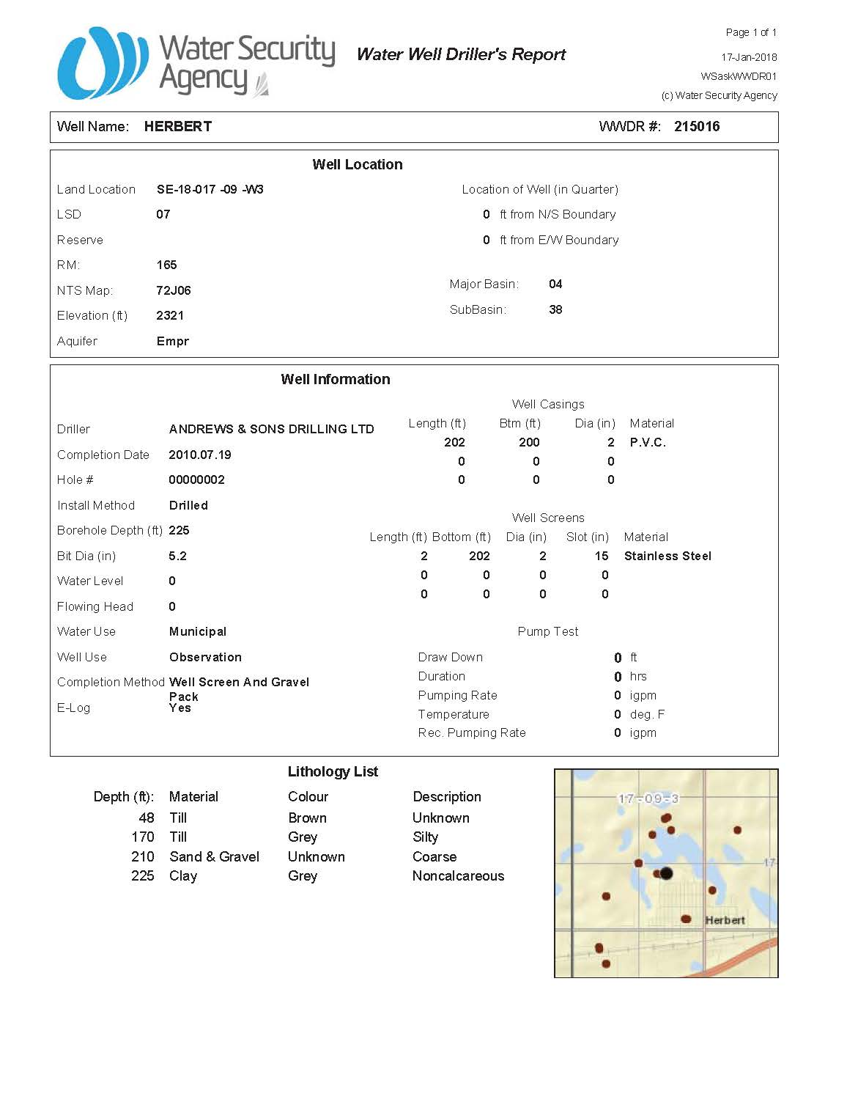

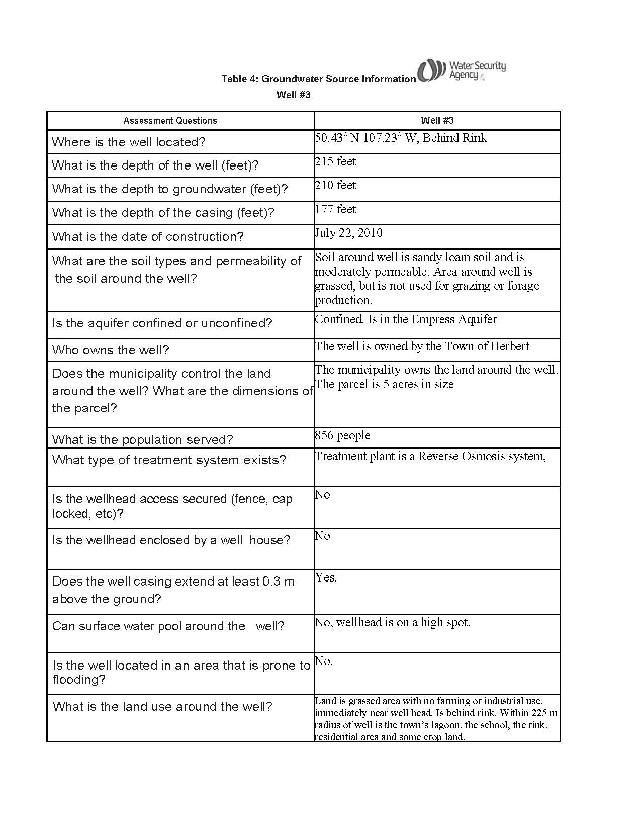

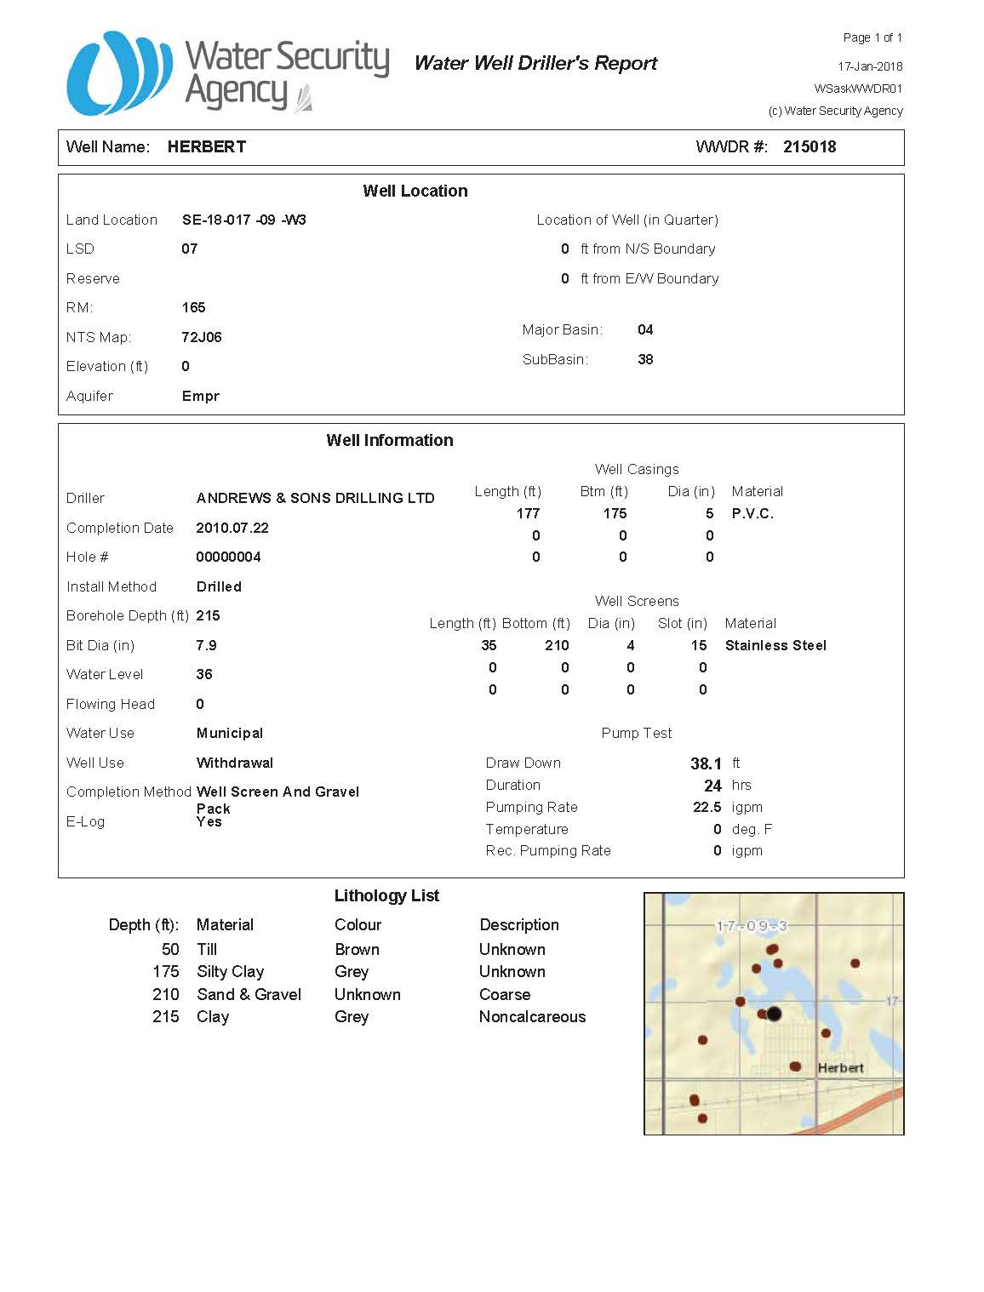

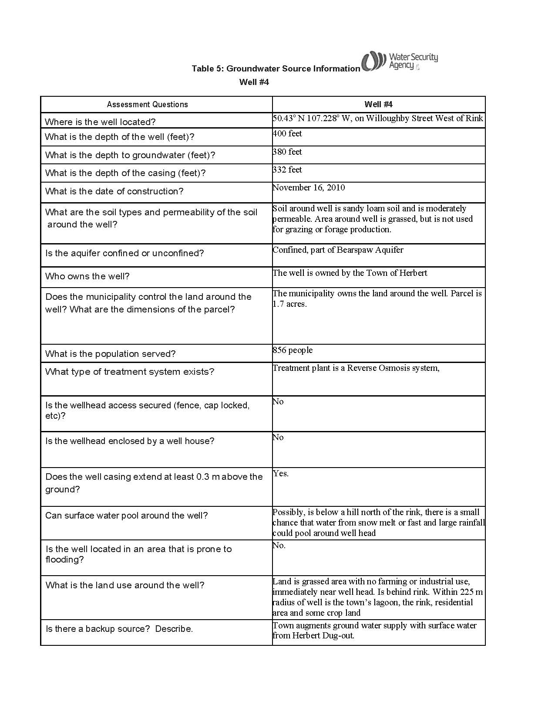

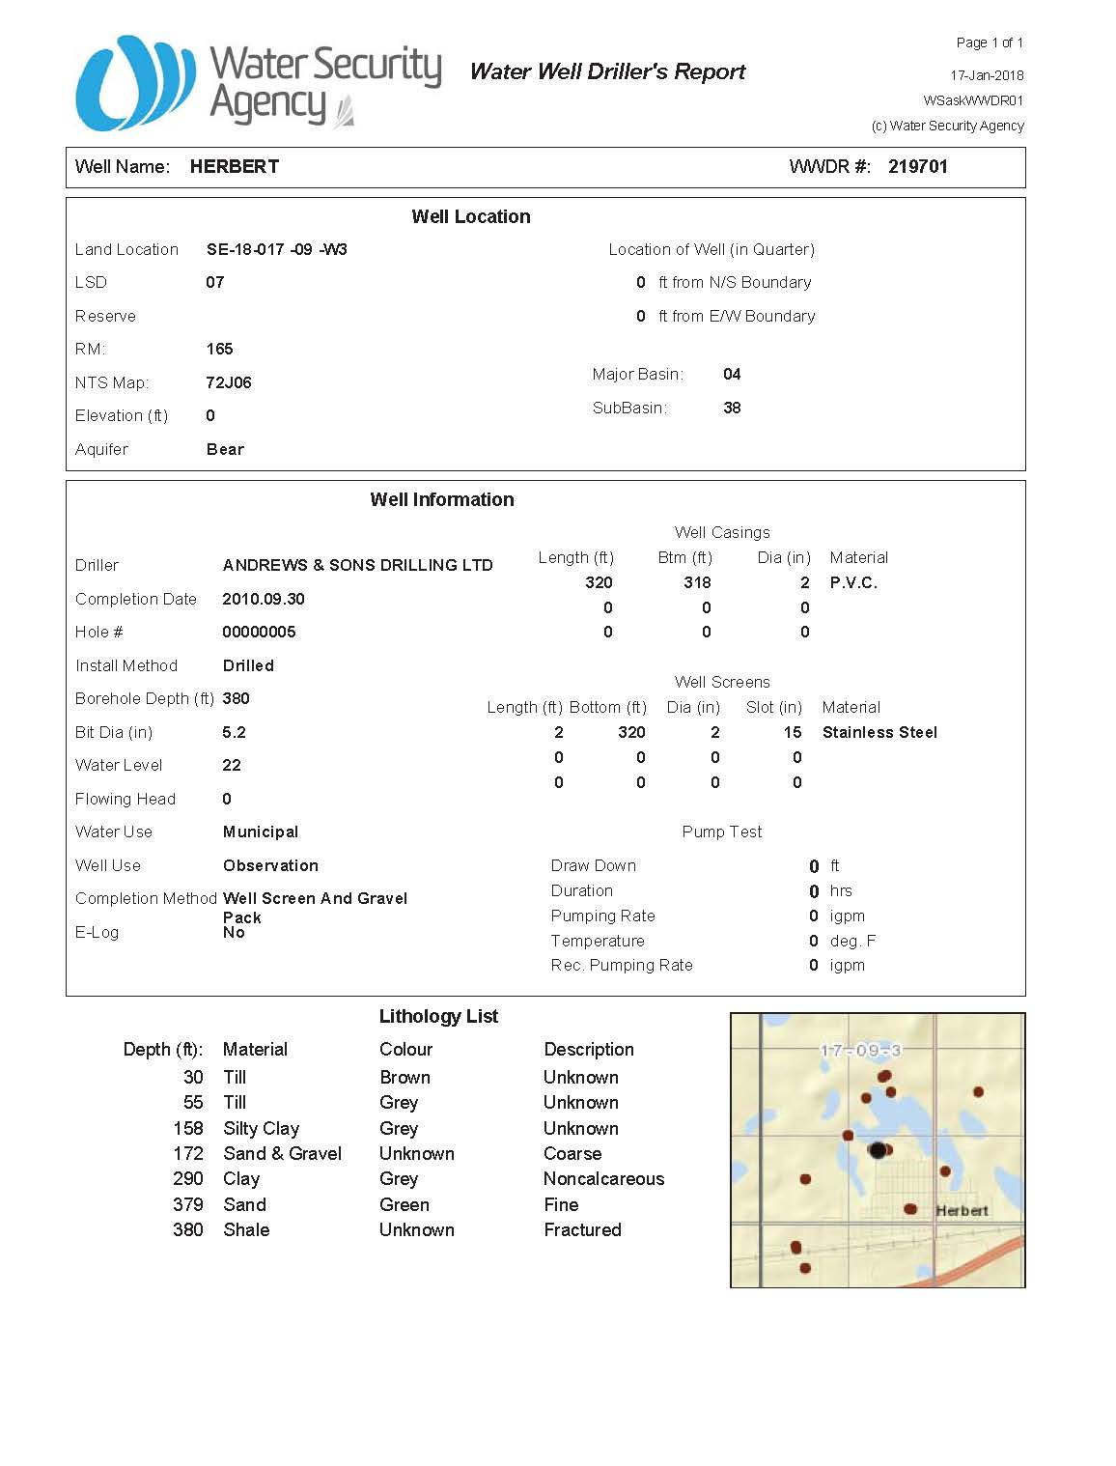

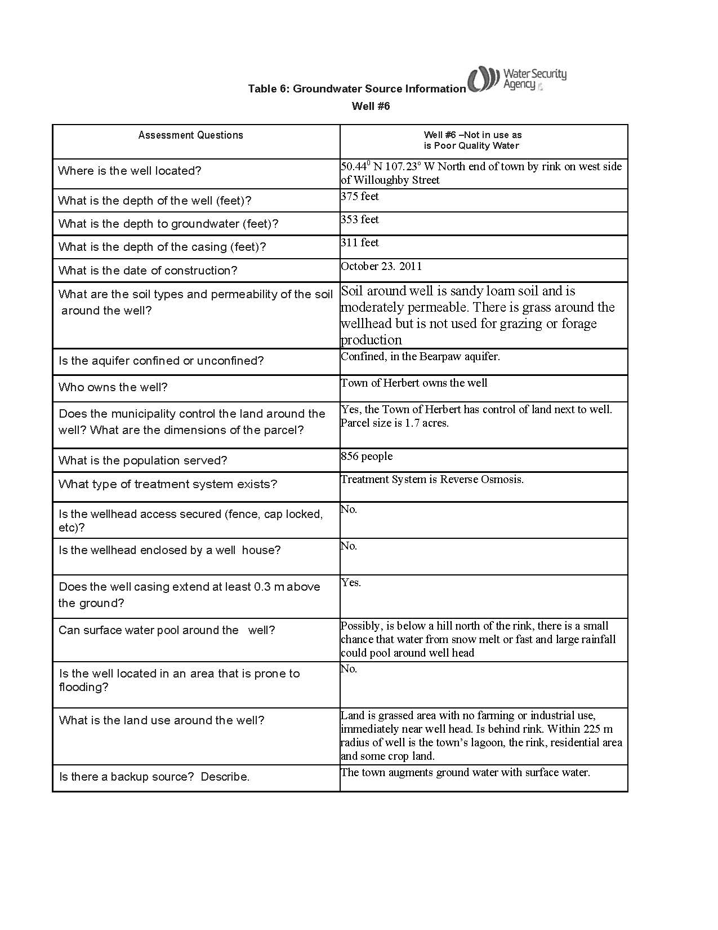

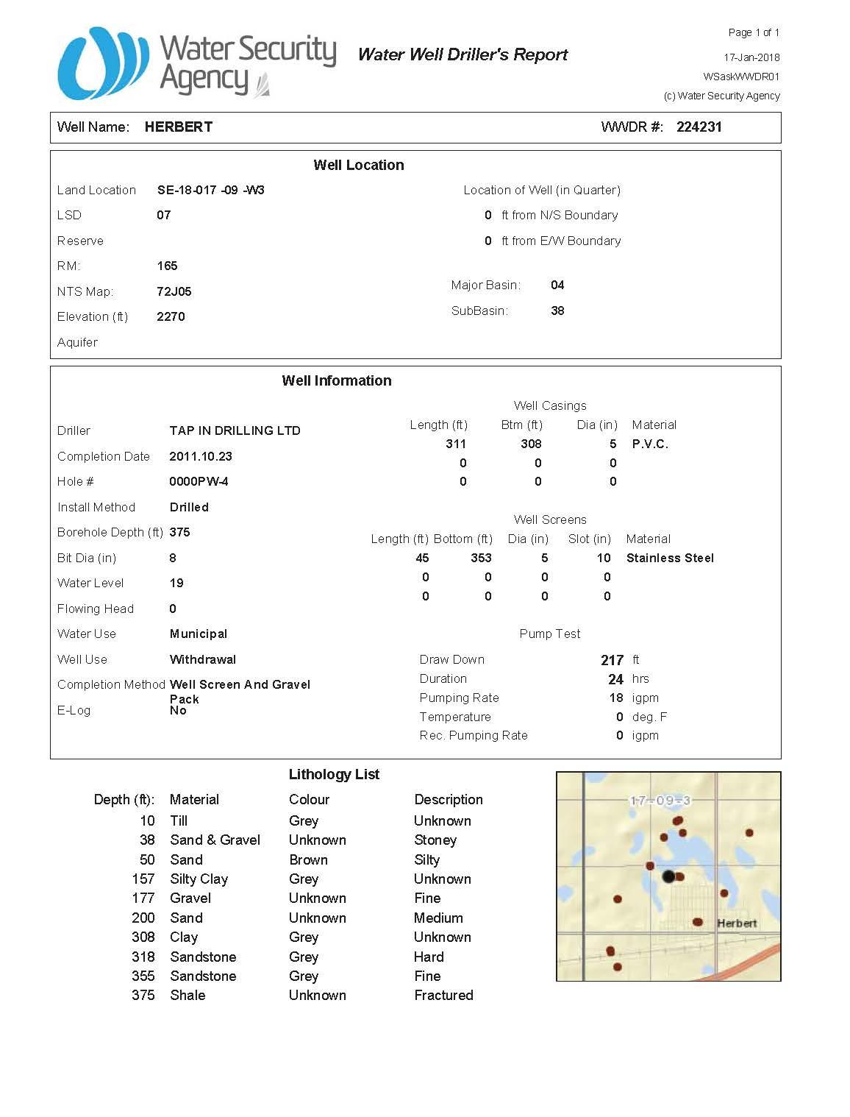

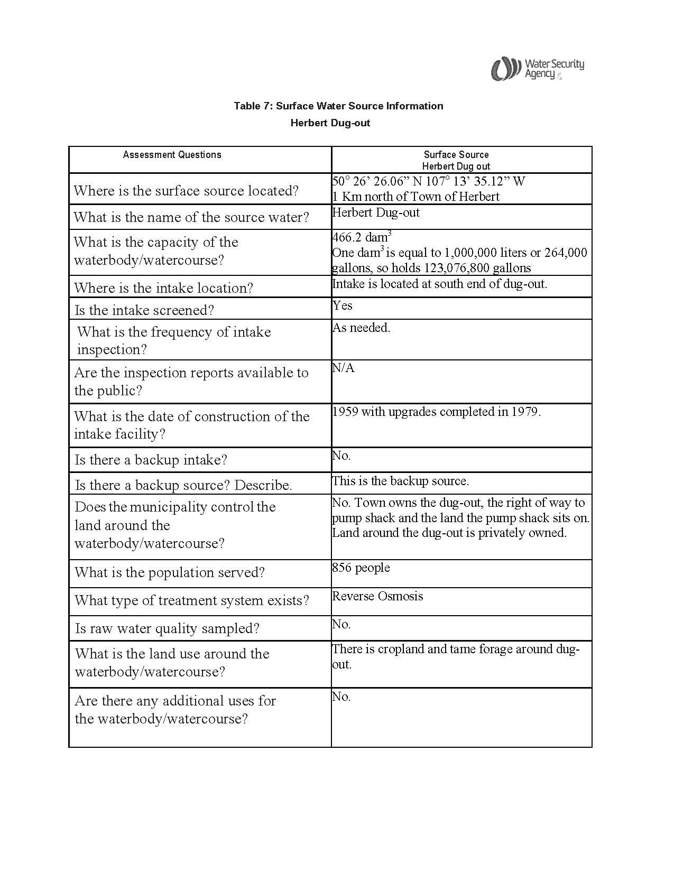

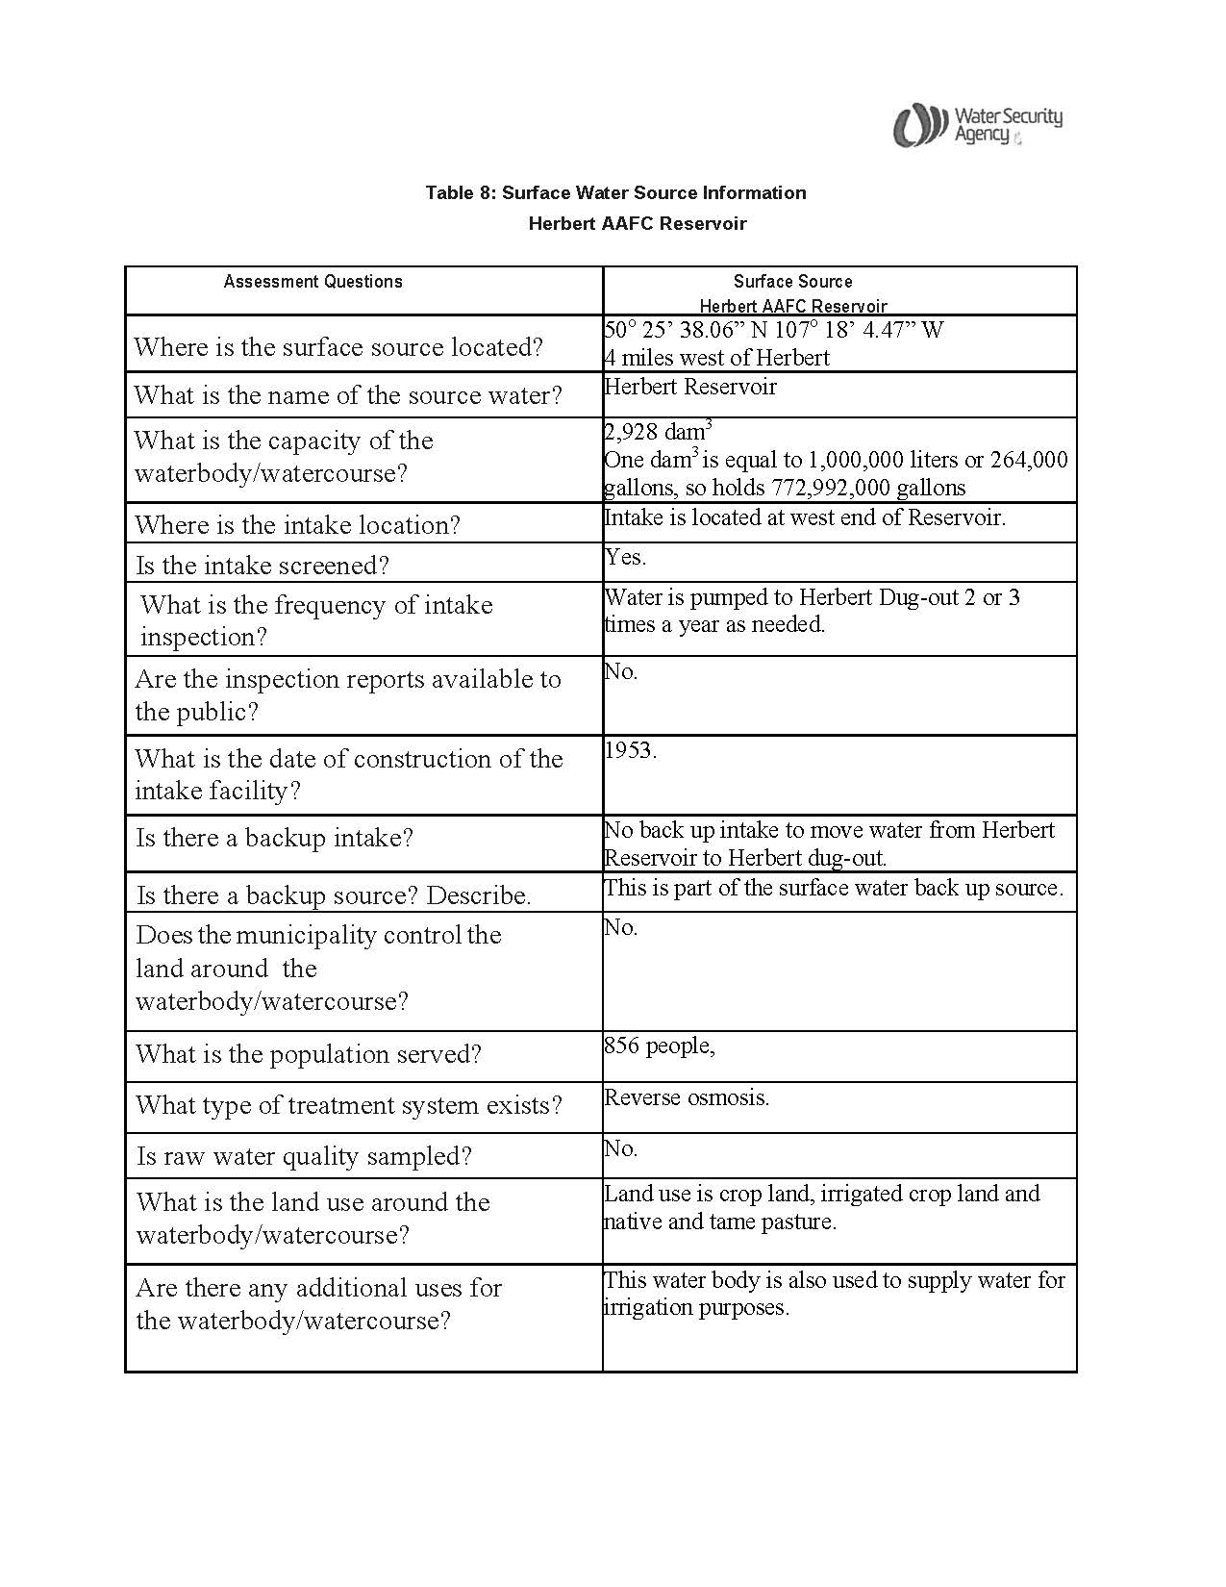

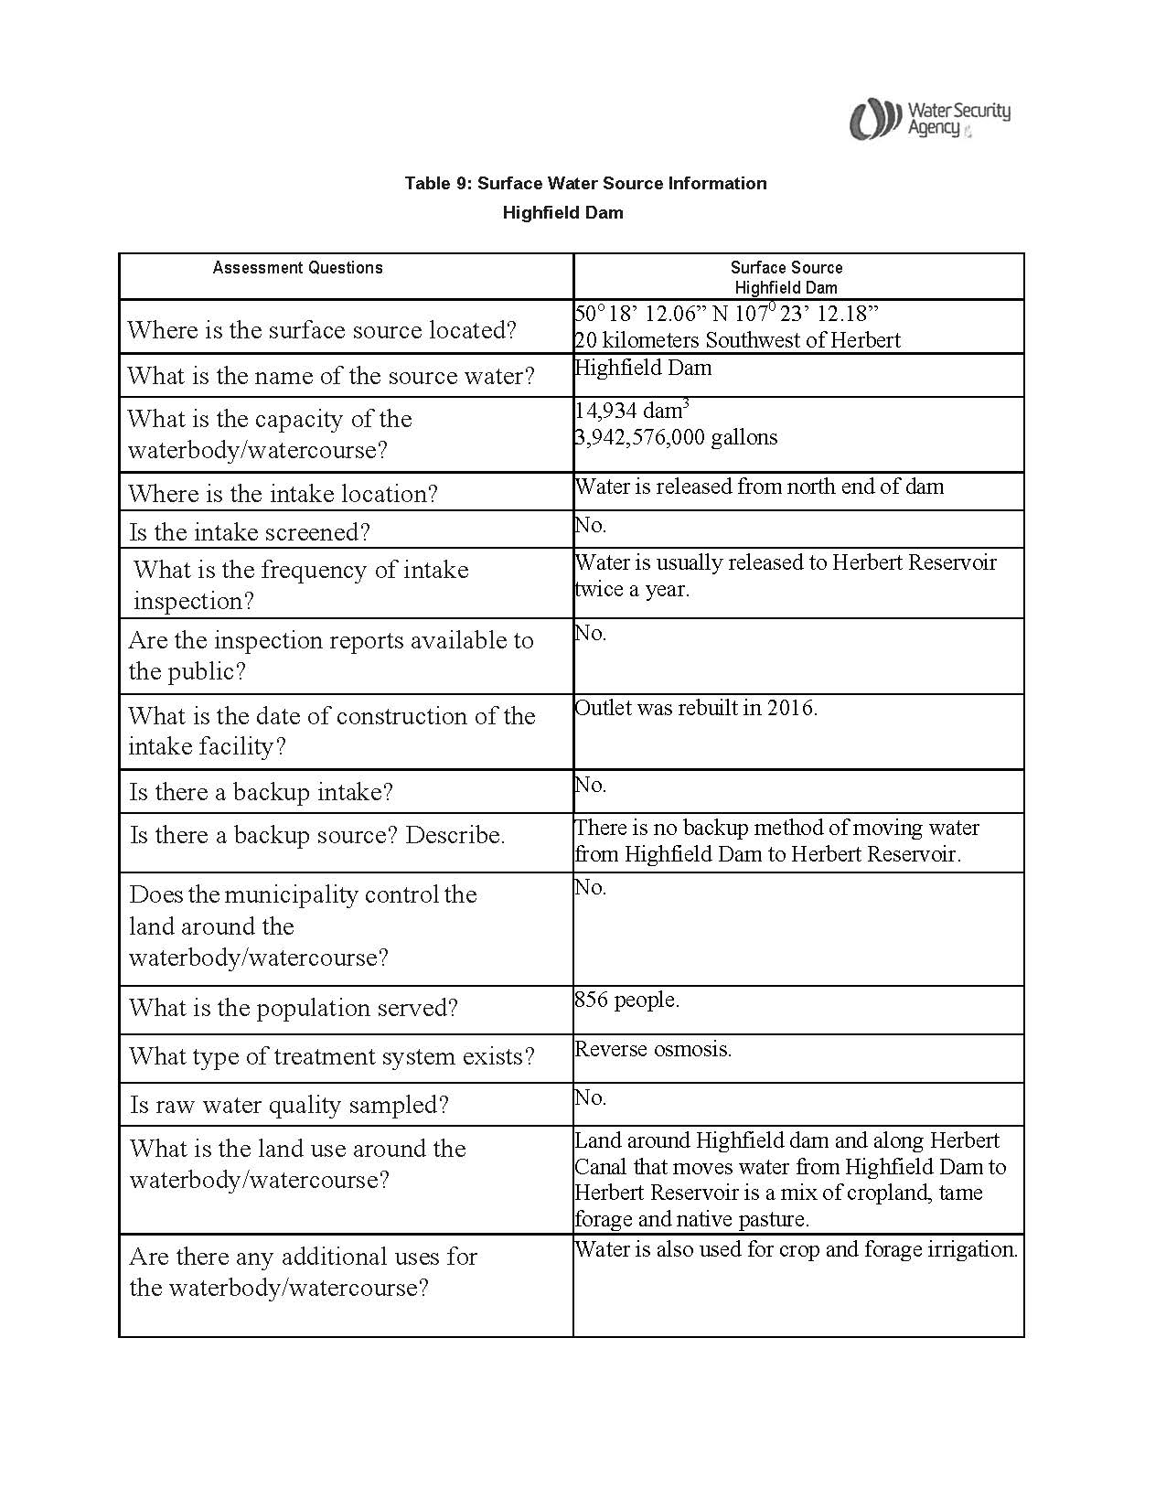

**4.2.2 Risk Inventory**

Table 10 lists the potential risks to contamination Herbert’s source water as determined by the SWP Planning Committee during Stage 2 of the SWP process.

**Table 10: Risk Inventory**

|  |  |  |  |  |
| --- | --- | --- | --- | --- |
|  | **Risk/Contamination Event (Existing/Potential) and Location** | **Management Responsibility** | **Contaminant of Concern** | **Type of Source**  **(Human/Natural)**  **(Point/Non-point Source)** |
| a) | Agricultural Chemical Drift into Dug-out, Reservoir, Highfield Dam or canals. (Potential) | Private | Agricultural Chemicals. | Human.  Non-Point Source. |
| b) | Agricultural Chemical Spill into Dug-out, Reservoir, Highfield Dam or canals. (Potential) | Private | Agricultural Chemicals. | Human.  Non-Point Source. |
| c) | Surface Run-off containing Agricultural Chemical into Dug-out, Reservoir, Highfield Dam or canals. (Potential) | Private | Agricultural Chemicals. | Human.  Point Source. |
| d) | Surface Run-off containing Agricultural Fertilizers into Dug-out, Reservoir, Highfield Dam or canals. (Potential) | Private | Nutrient Loading especially Nitrogen and Phosphorous. | Human.  Point Source. |
| e) | Surface Run-off containing livestock manure into dug-out, Reservoir, Highfield Dam or canals.  (Potential) | Private | Nutrient Loading especially Nitrogen and Phosphorous.  Pathogens poisonous to humans, wildlife and livestock. | Human.  Point Source. |
| f) | Train derailment spilling into canal. (Potential) | Private | Chemicals. | Human.  Point Source. |
| g) | Spills into canal where it crosses highway. (Potential) | Private | Chemicals. | Human.  Point Source. |
| h) | Water in dug-out not aerated properly. (Existing) | Municipal | Algal Growth. | Human.  Point Source. |

**Table 10 continued: Risk Inventory**

|  |  |  |  |  |
| --- | --- | --- | --- | --- |
|  | **Risk/Contamination Event (Existing/Potential) and Location** | **Management Responsibility** | **Contaminant of Concern** | **Type of Source**  **(Human/Natural)**  **(Point/Non-point Source)** |
| j) | Transfer of ownership of Highfield Dam to Province of Saskatchewan from Government of Canada. Non-transfer of Herbert Reservoir and canals. (Existing) | Federal and Provincial Governments |  | Human.  Non-point Source. |
| k) | Quantity of ground water available to Water Treatment Plant. (Existing) | Municipal |  | Natural.  Non-Point Source. |
| l) | Quality of ground water available to Water Treatment Plant. (Existing) | Municipal |  | Natural.  Non-Point Source. |
| m) | Water from Herbert Reservoir and/or Highfield Dam is not available. (Potential) | Municipal  Federal and Provincial Governments | Chemicals.  Pathogens poisonous to humans, wildlife and livestock.  Organic Matter.  Nutrient Loading especially Nitrogen and Phosphorous. | Human/Natural.  Point/Non-Point Source. |
| n) | Continued increase in water use by residents of the Town of Herbert. (Potential) | Municipal |  | Human.  Non-Point Source. |
| o) | Increased need for water due to increase in population or industry. (Potential) | Municipal |  | Human.  Non-Point Source. |
| p) | Well heads not protected from accidental contamination. (Potential) | Municipal | Unknown. | Human/Natural.  Point/Non-Point Source. |
| q) | Well heads are in area that can be accessed by public, vandalism is possible. (Potential) | Municipal | Unknown. | Human.  Point Source. |

**4.2.3 Qualitative Risk Assessments**

The events listed were assessed by the members of the committee using a qualitative risk assessment approach. This approach was adapted from the British Columbia Ministry of Health, Living and Sport-Comprehensive Drinking Water Source to Tap Assessment Guidelines 2010. Table 11 describes the criteria used to determine the likelihood of a contamination event occurring and breaks it down into descriptors of rare, unlikely, possible, likely and almost certain. Table 12 describes the criteria used to determine the consequence should a contamination event occur and breaks it down to descriptors of insignificant, minor, moderate, major and catastrophic. Table 13 combines the likelihood of a contamination event happening with the consequence of the event happening to develop a risk ranking score of that contamination event happening. This score gave the committee direction how prioritize the potential contamination events that they had identified. These final risk rankings are noted in Table 14. Table 15 lists the risk rankings for each potential contamination event and the voluntary land management action proposed by the committee to eliminate or mitigate the risks identified. Table 16 lists the Risk Management Plan as developed by the SWP committee.

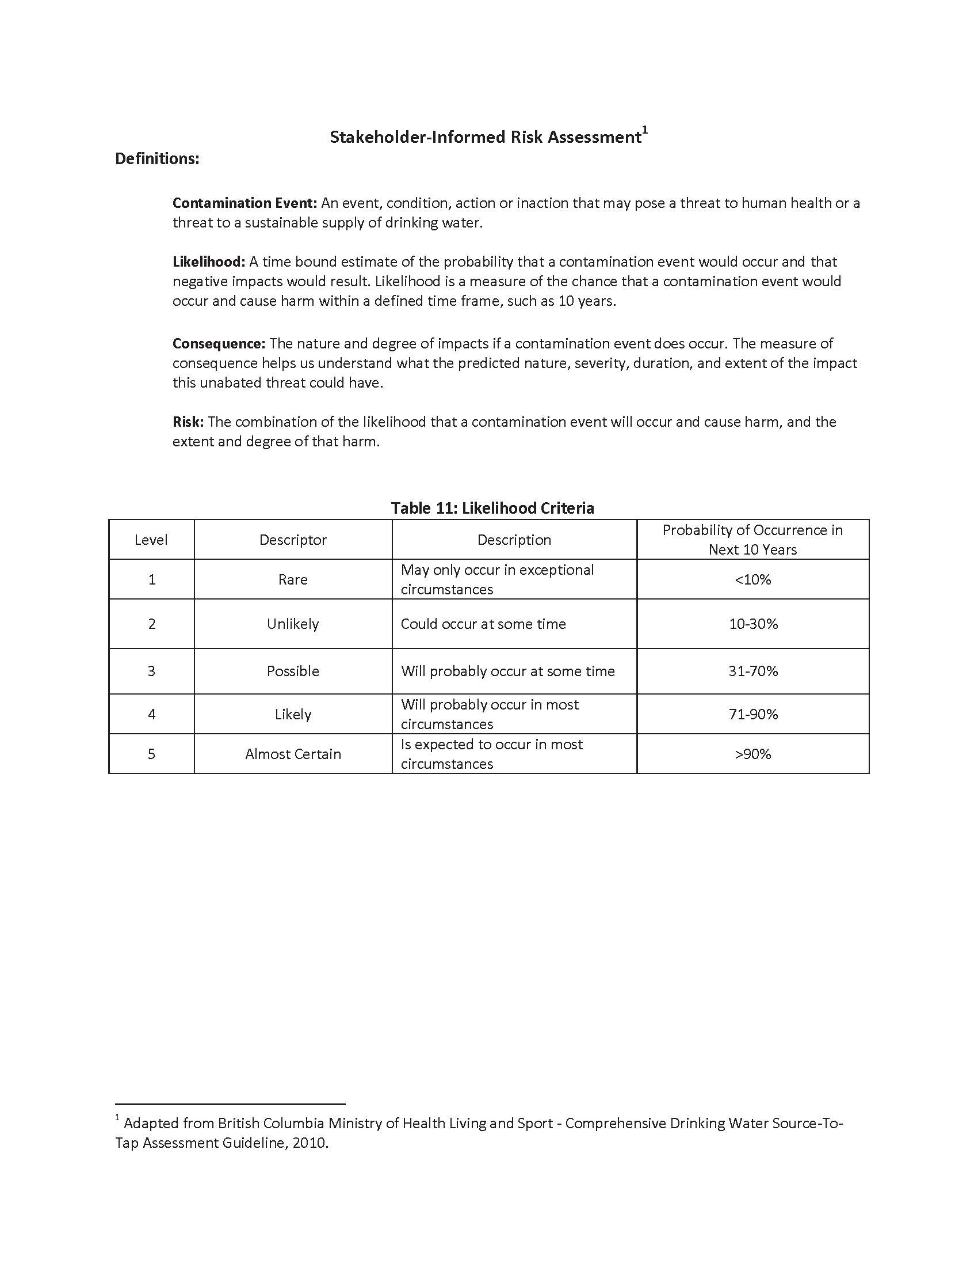

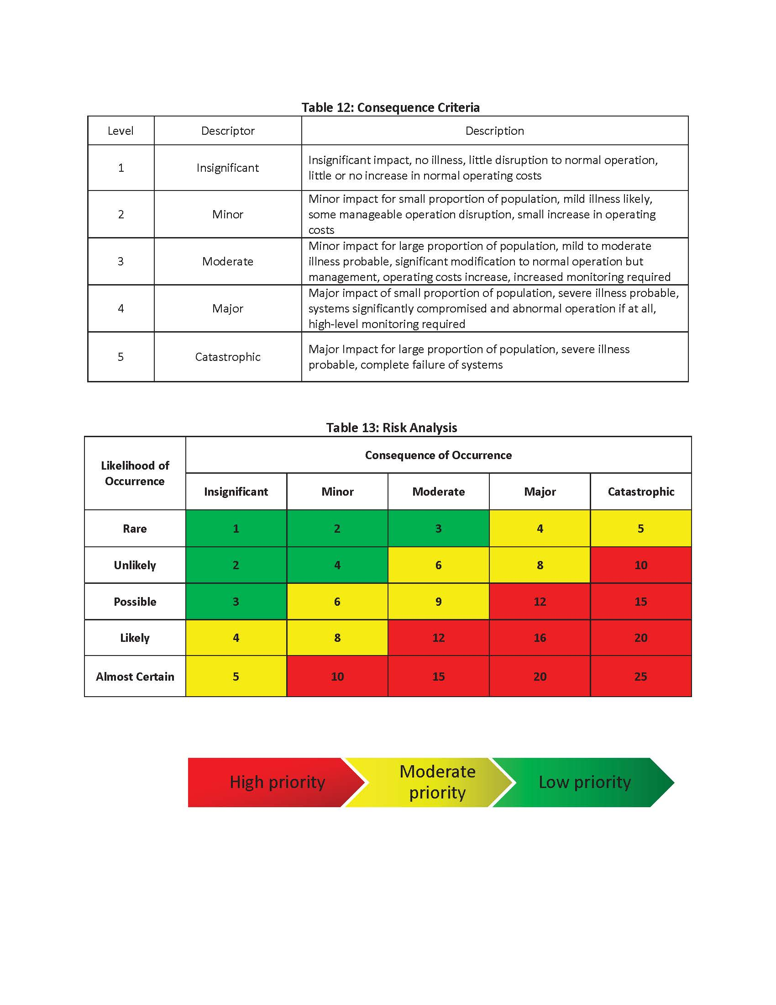

**Table 14: Qualitative Risk Assessment**

|  |  |  |  |  |  |
| --- | --- | --- | --- | --- | --- |
|  | **Contamination Event** | **Likelihood** | **Consequence** | **Risk Ranking** | **Additional Information** |
| a) | Agricultural Chemical Drift into Dug-out, Reservoir, Highfield Dam or canals. | 5 | 1 | 5 |  |
| b) | Agricultural Chemical Spill into Dug-out, Reservoir, Highfield Dam or canals. | 3 | 3 | 9 |  |
| c) | Surface Run-off containing Agricultural Chemical into Dug-out, Reservoir, Highfield Dam or canals. | 3 | 2 | 6 |  |
| d) | Surface Run-off containing Agricultural Fertilizers into Dug-out, Reservoir, Highfield Dam or canals. | 3 | 2 | 6 |  |
| e) | Surface Run-off containing livestock manure into dug-out, Reservoir, Highfield Dam or canals. | 3 | 4 | 12 |  |
| f) | Train derailment spilling into canal. | 1 | 2 | 2 | If contents from train spill into canal water can be kept out of Herbert Reservoir. Have roughly 1 day to contain spills west of Rush Lake where tracks cross over Herbert Main Canal.  Water in canal only runs for 2 - 3 weeks at a time twice a year. |
| g) | Spills into canal where it crosses highway. | 1 | 2 | 2 | If contents from vehicle spill into canal water can be kept out of Herbert Reservoir. Have roughly 1 day to contain spills west of Rush Lake where Highway #1 crosses over Herbert Main Canal.  Water in canal only runs for 2 - 3 weeks at a time twice a year. |
| h) | Water in dug-out not aerated properly. | 5 | 2 | 10 |  |
| i) | Large numbers of wildlife especially geese in Herbert Reservoir. | 5 | 3 | 15 | Water can be pumped to Herbert Dug-out before geese arrive. |
| j) | Transfer of ownership of Highfield Dam to Province of Saskatchewan from Government of Canada. Non-transfer of Herbert Reservoir and canals. | 5 | 3 | 15 | This may cause some disruption of service especially transfer of water from Highfield Dam to Herbert Reservoir, may cause issues with pump |

**Table 14 continued: Qualitative Risk Assessment**

|  |  |  |  |  |  |
| --- | --- | --- | --- | --- | --- |
|  | **Contamination Event** | **Likelihood** | **Consequence** | **Risk Ranking** | **Additional Information** |
| k) | Quantity of ground water available to Water Treatment Plant. | 4 | 2 | 8 |  |
| l) | Quality of ground water available to Water Treatment Plant. | 4 | 3 | 12 | Well water has high levels of Aluminum, Iron, Manganese, Zinc, Total Alkalinity and Sodium. |
| m) | Water from Herbert Reservoir and/or Highfield Dam is not available. | 2 | 5 | 10 | If water gets contaminated and cannot be contained or there is not enough available to pump into Herbert Dug-out |
| n) | Continued increase in water use by residents of the Town of Herbert. | 4 | 4 | 16 |  |
| o) | Increased need for water due to increase in population or industry. | 3 | 5 | 15 | There is nothing at this time to indicate that there will be a large increase in population in the near future. |
| p) | Well heads not protected from accidental contamination. | 2 | 5 | 10 |  |
| q) | Well heads are in area that can be accessed by public, vandalism is possible. | 1 | 5 | 5 |  |

**4.3 Land Management Actions**

**Table 15: Voluntary Risk Management Actions**

|  |  |  |  |  |
| --- | --- | --- | --- | --- |
|  | **Contamination Event** | **Risk Ranking** | **Existing Risk Management Actions** | **Proposed Risk Management Actions** |
| a) | Agricultural Chemical Drift into Dug-out, Reservoir, Highfield Dam or canals. | 5 |  | Educate about spray drift effects and the proper time to spray.  Encourage the implementation and management of Riparian Buffers. |
| b) | Agricultural Chemical Spill into Dug-out, Reservoir, Highfield Dam or canals. | 9 |  | Education about responses to spills.  Encourage the implementation and management of Riparian Buffers. |
| c) | Surface Run-off containing Agricultural Chemical into Dug-out, Reservoir, Highfield Dam or canals. | 6 |  | Education about 4R Nutrient Stewardship to use Right product at the right rate at right time and right place.  Encourage the implementation and management of Riparian Buffers. |
| d) | Surface Run-off containing Agricultural Fertilizers into Dug-out, Reservoir, Highfield Dam or canals. | 6 |  | Education about 4R Nutrient Stewardship to use Right product at the right rate at right time and right place.  Education about variable rate fertilizer technology to reduce waste and to reduce waste near riparian areas.  Encourage the implementation and management of Riparian Buffers. |
| e) | Surface Run-off containing livestock manure into dug-out, Reservoir, Highfield Dam or canals. | 12 | Implementation of Beneficial Management Practices to relocate livestock facilities and control run-off from these facilities. Implementation of BMPs to relocate watering systems and fencing to keep livestock out of waterbodies. | Continued education and implementation of the BMPs to Protect water sources.  Encourage the implementation and management of Riparian Buffers. |
| f) | Train derailment spilling into canal. | 2 |  | Eliminate water flow into Herbert Reservoir from canal. This needs to be done within one day of event |
| g) | Spills into canal where it crosses highway. | 2 |  | Eliminate water flow into Herbert Reservoir from canal. This needs to be done within one day of event. |

**Table 15 continued: Voluntary Risk Management Actions**

|  |  |  |  |  |
| --- | --- | --- | --- | --- |
|  | **Contamination Event** | **Risk Ranking** | **Existing Risk Management Actions** | **Proposed Risk Management Actions** |
| h) | Water in dug-out not aerated properly. | 10 |  | Move aerators closer to intake so that higher quality water is taken in.  Add more aeration into Herbert Dug-out. |
| i) | Large numbers of wildlife especially geese in Herbert Reservoir. | 15 |  | Water sampling and testing to see what water quality issues this causes.  Pump water from Reservoir to Dug-out before geese arrive in the fall.  Investigate solutions to keep geese off of reservoir during fall migration. |
| h) | Transfer of ownership of Highfield Dam to Province of Saskatchewan from Government of Canada. Non-transfer of Herbert Reservoir and canals. | 15 |  | Confirm which organization/government is taking control of which waterbody and canal.  Education of stakeholders and governments about Herbert’s water supply and the importance of the reservoirs and the issues that could arise from the change in control. |
| j) | Quantity of ground water available to Water Treatment Plant. | 8 | Addition of surface water when required. | Investigate cost of bringing in more groundwater including new wells and pipeline costs.  Search for more groundwater sources if it is cost effective.  Investigate if surface water alone can work for Town of Herbert.  Set water use plan and testing regimen. |
| k) | Quality of ground water available to Water Treatment Plant. | 12 | Addition of surface water when required. | Search for high quality groundwater sources that could be moved to Water Treatment Plant via pipeline and the cost effectiveness of these sources. |

**Table 15 continued: Voluntary Risk Management Actions**

|  |  |  |  |  |
| --- | --- | --- | --- | --- |
|  | **Contamination Event** | **Risk Ranking** | **Existing Risk Management Actions** | **Proposed Risk Management Actions** |
| l) | Water from Herbert Reservoir and/or Highfield Dam is not available. | 10 |  | Investigate cost of bringing in more groundwater including new wells and pipeline costs.  Search for more groundwater sources if it is cost effective.  Investigate if surface water alone can work for Town of Herbert.  Ensure that there is enough supply at the Herbert Dug-out and/or Reservoir to cover any issues that may occur. |
| m) | Continued increase in water use by residents of the Town of Herbert. | 16 | Addition of surface water as required. | Investigate feasibility and cost of water pipeline from wells outside of Herbert.  Upgrade systems at Water Treatment Plant.  Implement Water Conservation education such as use of rain barrels to save water to water plants, gardens, etc. place articles in Herbert Herald, work with the school to promote water conservation and watershed health.  Investigate pricing option to promote conservation and possibly fund upgrades to the system. |
| n) | Increased need for water due to increase in population or industry. | 15 | Addition of surface water as required. | Investigate feasibility and cost of water pipeline from wells outside of Herbert.  Upgrade systems at both Water Treatment Plant and Wastewater Treatment Plant.  Implement Water Conservation education such as use of rain barrels to save water to water plants, gardens, etc. Articles in Herbert Herald, work with the school to promote water conservation and watershed health.  Investigate pricing option to promote conservation and fund upgrades to the system. |

**Table 15 continued: Voluntary Risk Management Actions**

|  |  |  |  |  |
| --- | --- | --- | --- | --- |
|  | **Contamination Event** | **Risk Ranking** | **Existing Risk Management Actions** | **Proposed Risk Management Actions** |
| o) | Well heads not protected from accidental contamination. | 10 |  | Build infrastructure to protect well head such as a berm to keep water away from well head. |
| p) | Well heads are in area that can be accessed by public, vandalism is possible. | 5 |  | Construct fence around wells and well heads to keep public away from well heads. |

**Table 16: Risk Management Action Plan**

|  |  |  |  |  |  |
| --- | --- | --- | --- | --- | --- |
|  | **Contamination Event** | **Risk Management Actions** | **Partners/Stakeholders** | **Potential Funding Source and Estimate Cost** | **Proposed Completion Timeline**  **< 2 years**  **2-5 years**  **>5 years** |
| a) | Agricultural Chemical Drift into Dug-out, Reservoir, Highfield Dam or canals. | Educate about spray drift effects and the proper time to spray. | Landowners | Saskatchewan Ministry of Agriculture (MOA)/SCCWS  In kind | < 2 years |
| Encourage the implementation and management of Riparian Buffers. | Landowners/WSA/SCCWS | MOA  $35/acre seeded for Riparian Buffer | 2-5 years |
| b) | Agricultural Chemical Spill into Dug-out, Reservoir, Highfield Dam or canals. | Education about responses to spills. | Landowners/WSA/SCCWS | Government of Saskatchewan (GoS)  In kind | < 2years |
| Encourage the implementation and management of Riparian Buffers. | Landowners/WSA/SCCWS | MOA  $35/acre seeded for Riparian Buffer | 2-5 years |
| c) | Surface Run-off containing Agricultural Chemical into Dug-out, Reservoir, Highfield Dam or canals. | Education about 4R Nutrient Stewardship to use Right product at the right rate at right time and right place. | Landowners/WSA/SCCWS/ MOA | MOA/SCCWS  In kind | 2-5 years |
| Encourage the implementation and management of Riparian Buffers. | Landowners/WSA/SCCWS | MOA  $35/acre seeded for Riparian Buffer | 2-5 years |
| d) | Surface Run-off containing Agricultural Fertilizers into Dug-out, Reservoir, Highfield Dam or canals. | Education about 4R Nutrient Stewardship to use Right product at the right rate at right time and right place. | Landowners/WSA/SCCWS/ MOA | MOA/SCCWS  In kind | 2-5 years |
| Education about variable rate fertilizer technology to reduce waste and to reduce waste near riparian areas. | Landowners/WSA/SCCWS/ MOA | MOA/SCCWS  In kind | 2-5 years |

**Table 16 continued: Risk Management Action Plan**

|  |  |  |  |  |  |
| --- | --- | --- | --- | --- | --- |
|  | **Contamination Event** | **Risk Management Actions** | **Partners/Stakeholders** | **Potential Funding Source and Estimate Cost** | **Proposed Completion Timeline**  **< 2 years**  **2-5 years**  **>5 years** |
| e) | Surface Run-off containing livestock manure into dug-out, Reservoir, Highfield Dam or canals. | Continued education and implementation of the BMPs to Protect water sources. | Landowners/WSA/SCCWS/ MOA | MOA through targeted Farm Stewardship Programming  SCCWS/In kind | 2-5 years |
| Encourage the implementation and management of Riparian Buffers. | Landowners/WSA/SCCWS | MOA  $35/acre seeded for Riparian Buffer | 2-5 years |
| f) | Train derailment spilling into canal. | Eliminate water flow into Herbert Reservoir from canal. This needs to be done within one day of spill. | WSA/AAFC | No funding required | < 2 years |
| g) | Spills into canal where it crosses highway. | Eliminate water flow into Herbert Reservoir from canal. This needs to be done within one day of spill. | WSA/AAFC | No funding required | < 2 years |
| h) | Water in dug-out not aerated properly. | Move aerators closer to intake so that higher quality water is taken in.  Add more aeration into Herbert Dug-out. | Town of Herbert/ WSA | Government of Saskatchewan/WSA  $10,000 | < 2 years |
| i) | Large numbers of wildlife especially geese in Herbert Reservoir. | Water sampling and testing to see what water quality issues this causes. | Town of Herbert /WSA/SCCWS | GoS/Environment and Climate Change Canada  $5,000  SCCWS in kind | 2-5 years |
| Pump water from Reservoir to Dug-out before geese arrive in the fall. | Town of Herbert/WSA/AAFC | No cost | 2-5 years |

**Table 16 continued: Risk Management Action Plan**

|  |  |  |  |  |  |
| --- | --- | --- | --- | --- | --- |
|  | **Contamination Event** | **Risk Management Actions** | **Partners/Stakeholders** | **Potential Funding Source and Estimate Cost** | **Proposed Completion Timeline**  **< 2 years**  **2-5 years**  **>5 years** |
| h) | Transfer of ownership of Highfield Dam to Province of Saskatchewan from Government of Canada. Non-transfer of Herbert Reservoir and canals. | Confirm which organization/government is taking control of which waterbody and canal. | Town of Herbert, AAFC, WSA | No Funding required | < 2 years |
| Education of stakeholders and governments about Herbert’s water supply and the importance of the reservoirs and the issues that could arise from the change in control. | Town of Herbert, AAFC, WSA, Rural Municipalities | No funding required | < 2 years |
| j) | Quantity of ground water available to Water Treatment Plant. | Investigate cost of bringing in more groundwater including new wells and pipeline costs. | Town of Herbert, WSA | Government of Saskatchewan  $10,000 for study | 2-5 years |
| Search for more groundwater sources if it is cost effective. | Town of Herbert, WSA | Government of Saskatchewan  $10,000 for study | 2-5 years |
| Investigate if surface water alone can work for Town of Herbert. | Town of Herbert, WSA | Government of Saskatchewan  $10,000 for study | 2-5 years |
| Set water use plan and testing regimen. | Town of Herbert, WSA, SCCWS | GoS, Environment and Climate Change Canada  $20,000 | 2-5 years |
| k) | Quality of ground water available to Water Treatment Plant. | Search for high quality groundwater sources that could be moved via pipeline to Water Treatment Plant and the cost effectiveness of these sources and a pipeline. | Town of Herbert, WSA | Government of Saskatchewan  $10,000 for study | 2-5 years |

**Table 16 continued: Risk Management Action Plan**

|  |  |  |  |  |  |
| --- | --- | --- | --- | --- | --- |
|  | **Contamination Event** | **Risk Management Actions** | **Partners/Stakeholders** | **Potential Funding Source and Estimate Cost** | **Proposed Completion Timeline**  **< 2 years**  **2-5 years**  **>5 years** |
| l) | Water from Herbert Reservoir and/or Highfield Dam is not available. | Investigate cost of bringing in more groundwater including new wells and pipeline costs. | Town of Herbert, WSA | Government of Saskatchewan  $10,000 for study | 2-5 years |
| Search for more groundwater sources if it is cost effective.  Investigate if surface water alone can work for Town of Herbert. | Town of Herbert, WSA | Government of Saskatchewan  $10,000 for study | 2-5 years |
| Ensure that there is enough supply at the Herbert Dug-out and/or Reservoir to cover any issues that may occur. | Town of Herbert, WSA, AAFC | Government of Saskatchewan, AAFC  $10,000 for study | 2-5 years |
| m) | Continued increase in water use by residents of the Town of Herbert. | Investigate feasibility and cost of water pipeline from wells outside of Herbert. | Town of Herbert, WSA | Government of Saskatchewan  $10,000 for study | 2-5 years |
| Upgrade systems at both Water Treatment Plant and Wastewater Treatment Plant. | Town of Herbert, WSA | Government of Saskatchewan, Increasing costs to users | 2-5 years |
|  |
|  |  |  |  |
|  |  | Implement Water Conservation education such as use of rain barrels to save water to water plants, gardens, etc. place articles in Herbert Herald, work with the school to promote water conservation and watershed health. | Town of Herbert, SCCWS | Government of Saskatchewan,  SCCWS in kind | 2-5 years |
| Investigate pricing option to promote conservation and possibly fund upgrades to the system. | Town of Herbert, WSA | Government of Saskatchewan  $10,000 for study | 2-5 years |

**Table 16 continued: Risk Management Action Plan**

|  |  |  |  |  |  |
| --- | --- | --- | --- | --- | --- |
|  | **Contamination Event** | **Risk Management Actions** | **Partners/Stakeholders** | **Potential Funding Source and Estimate Cost** | **Proposed Completion Timeline**  **< 2 years**  **2-5 years**  **>5 years** |
| n) | Increased need for water due to increase in population or industry. | Investigate feasibility and cost of water pipeline from wells outside of Herbert. | Town of Herbert, WSA | Government of Saskatchewan  $10,000 for study | 2-5 years |
| Upgrade systems at both Water Treatment Plant and Wastewater Treatment Plant.  Implement Water | Town of Herbert, WSA | Government of Saskatchewan, Increasing costs to users | 2-5 years |
| Conservation education such as use of rain barrels to save water to water plants, gardens, etc. place articles in Herbert Herald, work with the school to promote water conservation and watershed health. | Town of Herbert, SCCWS | Government of Saskatchewan,  SCCWS in kind | 2-5 years |
| Investigate pricing option to promote conservation and possibly fund upgrades to the system. | Town of Herbert, WSA | Government of Saskatchewan  $10,000 for study | 2-5 years |
| o) | Well heads not protected from accidental contamination. | Build infrastructure to protect well head such as a berm to keep water away from well head. | Town of Herbert | Town of Herbert | 2-5 years |
| p) | Well heads are in area that can be accessed by public, vandalism is possible. | Construct fence around wells and well heads to keep public away from well heads. | Town of Herbert | Town of Herbert | 2-5 years |

**4.3.1 Analysis**

The Herbert Source Water Protection Committee identified some risks that are common to most municipal water systems. However, as the wells that supply source water to Herbert are deep wells in confined aquifers the committee did not rate the risk of contamination of these wells as high. When determining the risks to surface water sources the short terms concerns need to be the protection of the Herbert Dug-out as that is where the water for the Herbert Water Treatment Plant is immediately pulled from. One of the benefits of the extensive system that sends water to the Herbert Dug-out is that any contamination in the system can be isolated to that area and not moved to the next waterbody until the contamination is cleaned up. This exclusion of contaminated water from the Herbert Main Canal needs to be completed quickly as it takes roughly one day for water to run from west of Rush Lake to the Herbert Reservoir.

Relying on isolating contaminations is not a prudent move in the long term as there is a finite amount of water in the Dug-out. Given the usage numbers from 2017, there is approximately 3 years of water storage capability in the Dug-out. However, without a recharge of new water into the dug-out from the Herbert Reservoir water quality worsens and issues with the operation from the use of stagnant surface water at the WTP will increase. Therefore, it is essential that all possible risks along the system that send water to Herbert are addressed and all applicable land management actions are put into place.

The next stage of protection is at the Herbert Reservoir. As there is a significant agriculture presence immediately adjacent to the reservoir, riparian buffers need to be established on the crop and irrigation land and fences need to be erected on pasture land adjacent to the reservoir to keep livestock out of the water to protect the shoreline and water. There is only two years of storage capacity at the Herbert Reservoir for irrigation that is permitted to use water from Herbert Reservoir, provided Herbert uses no water in those two years. If the Herbert Reservoir cannot be filled from Highfield Dam, irrigation demands on both reservoirs could cause water levels to drop to where water cannot be pumped to the Herbert Dug-out. This would be especially true in dry years when irrigation needs may increase.

Given the system of waterbodies and water conveyances that get surface water to Herbert a water sampling regimen and water use plan tied to the sampling regimen are needed. SCCWS is working with the town of Herbert, WSA and other stakeholders to implement both as part of the Source Water Protection Plan.

**4.4 Implementation and Plan Review**

The Land Management Actions identified government and non-government stakeholders to lead the implementation of each action. Actions requiring funding are identified with the possible source of funding. If applicable proposed timelines are listed.

**4.5 Five Year Review**

Stage 5 of the Source Water Protection Process is to review the plan after 5 years. This review should include:

* Renewal of steering committee.
* Review of source water assessment including information gathered during the implementation phase.
* Updates to Land Management Actions if required.

This process will ensure that the SWP plan developed can evolve and be adapted to address new risks over time.

1. **Conclusion**

Herbert’s source water both ground water and surface water sources are good quality and not at risk by a particular contamination event. However, using one source only may create quantity issues for the town’s water supply. Using a blend of surface and ground water and with the system that transports surface water to Herbert’s WTP a unique situation is created. This situation requires constant monitoring by all stakeholders to ensure that Herbert’s residents continue to receive an abundant supply of high quality drinking water.

This SWP created and the Land Management actions included in it are not meant to replace regular maintenance or upgrades to the WTP. Rather this plan becomes one of the barriers in the multi barrier approach to reducing the risks to the source water. The application of the SWP, testing regimen and water use plan form a foundation for actions that mitigate and manage risks to the drinking water sources. The success of this plan, the testing regimen and water use plan is dependent on the development of partnerships of stakeholders and the continued support of the ongoing implementation of management actions at the local level.

Table 17- Glossary of Terms

|  |  |
| --- | --- |
| Term | Abbreviation |
| Government of Saskatchewan | GoS |
| Reverse Osmosis | RO |
| Saskatchewan Ministry of Agriculture | MOA |
| Source Water Protection | SWP |
| Swift Current Creek Watershed Stewards | SCCWS |
| Water Security Agency | WSA |
| Water Treatment Plant | WTP |